THEY LAID DOWN THEIR LIVES FOR US
A wall mounted stone near the top of the churchyard wall on Fraser Place commemorates Lewis Findlater and members of his family.
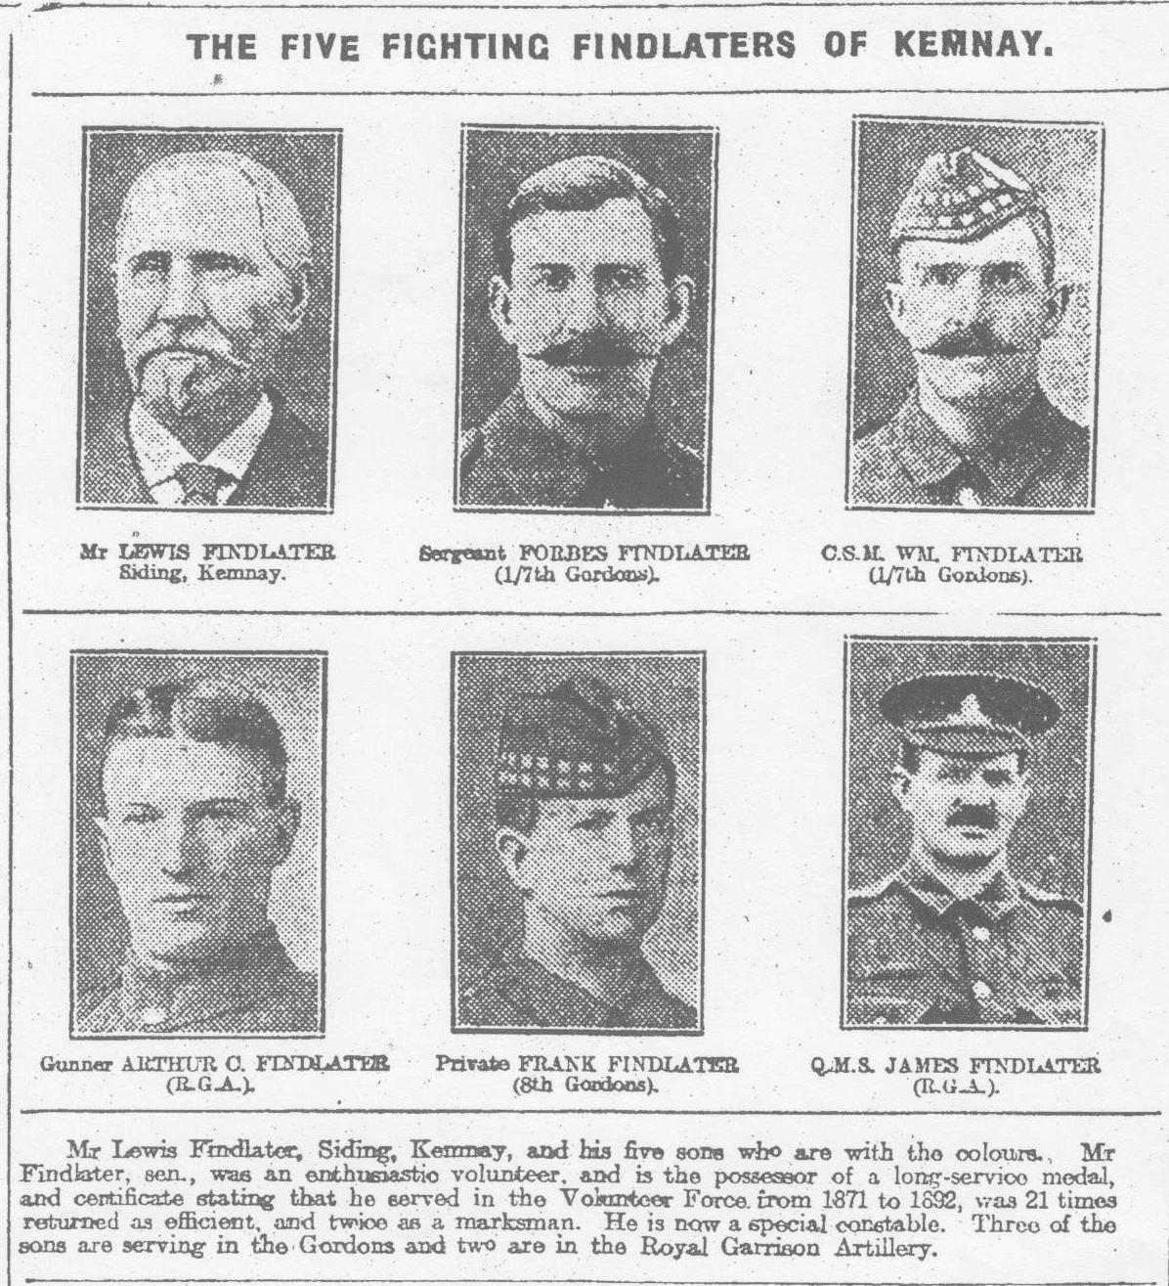
Lewis Findlater was born in the parish of Oyne around 1849 and came to Kemnay as a young man to work for Mr Still at the Mill of Kemnay. After a few years he gained employment at the quarries where he was to remain for the rest of his life.
The adjoining image appeared in the Evening Express on Monday January 17 1916 and shows five members of the Findlater family who were serving in the war. Sadly, three of them did not survive.
Sergeant Major Forbes Findlater (43) 1/7th Gordons, was killed on 7th July 1916 and was buried in Maroeuil British Cemetery, France , Plot 3 Row A, Grave 8.
Company Sergeant Major William Findlater (37) 1/7th Gordons suffered from a gastric ulcer for some 6 months which eventually perforated and he died at the Military Hospital in Woking, Surrey on 23rd August 1918. He was buried in the family plot in Kemnay Churchyard and to date, he does not have a CWGC stone.
Lance corporal Francis Findlater (19) 8/10th Gordons, was killed on 28th June 1916 and his name appears on the Loos Memorial, France, Panels 115 to 119.
He was one of a group of 2 officers and 60 men engaged in a night raid on the Germans. They were fired on by 3 machine guns and a few riflemen. Findlater and a sergeant reached the German wire where Findlater was killed. Attempts were made to cut the 10 mm thick wire, but it simply slipped out of the soldiers’ shears. Some 30 or 40 bombs were thrown into the German trench by this group of men, to little avail.

