PETRIE FAMILY
The wall mounted memorial round the corner from the Findlater memorial (November 2017) commemorates members of the Petrie family.
Andrew Petrie was born in Kennethmont and served his apprenticeship with James Howie, merchant in Huntly. Soon after completing his apprenticeship he moved to Aberdeen and it was not long before he set up on his own account as a grocer in the Green.
In 1876 he moved to Kemnay and commenced business as a general merchant in premises which were to become the nucleus of the Burnett Arms Hotel. In 1888 he moved to custom built premises on the corner of High Street and Station Road from where he carried on as a general merchant comprising; grocery, ironmongery, house furnishing, hardware, drapery, gent’s outfitting as well as an agency for the Town and County Bank.
The shop had a two door frontage to High Street with the entrance to the bank office on the corner. The window in the photo showing the hats is the present day window of ??
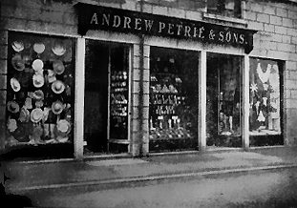
The business prospered and Andrew Petrie was joined in the business by three of his sons. The store in Monymusk was taken on and run in conjunction with the Kemnay business.
Mr Petrie took a keen interest in local affairs, being for many years a member of the School Board and the Parish Council. He was secretary of the Kemnay Hall Company for nearly twenty five years and precentor in the Free Church for a similar period.
Andrew Petrie died on 4th April 1908 aged 70 years, his widow, Annie Kemp, died on 12th July 1933 aged 84 years.

