GROWTH OF THE VILLAGE, PART 3
The area of land bounded by Station Road, High Street, St Bryde's Road, and the lane running down to Station Road, was originally divided into three plots.
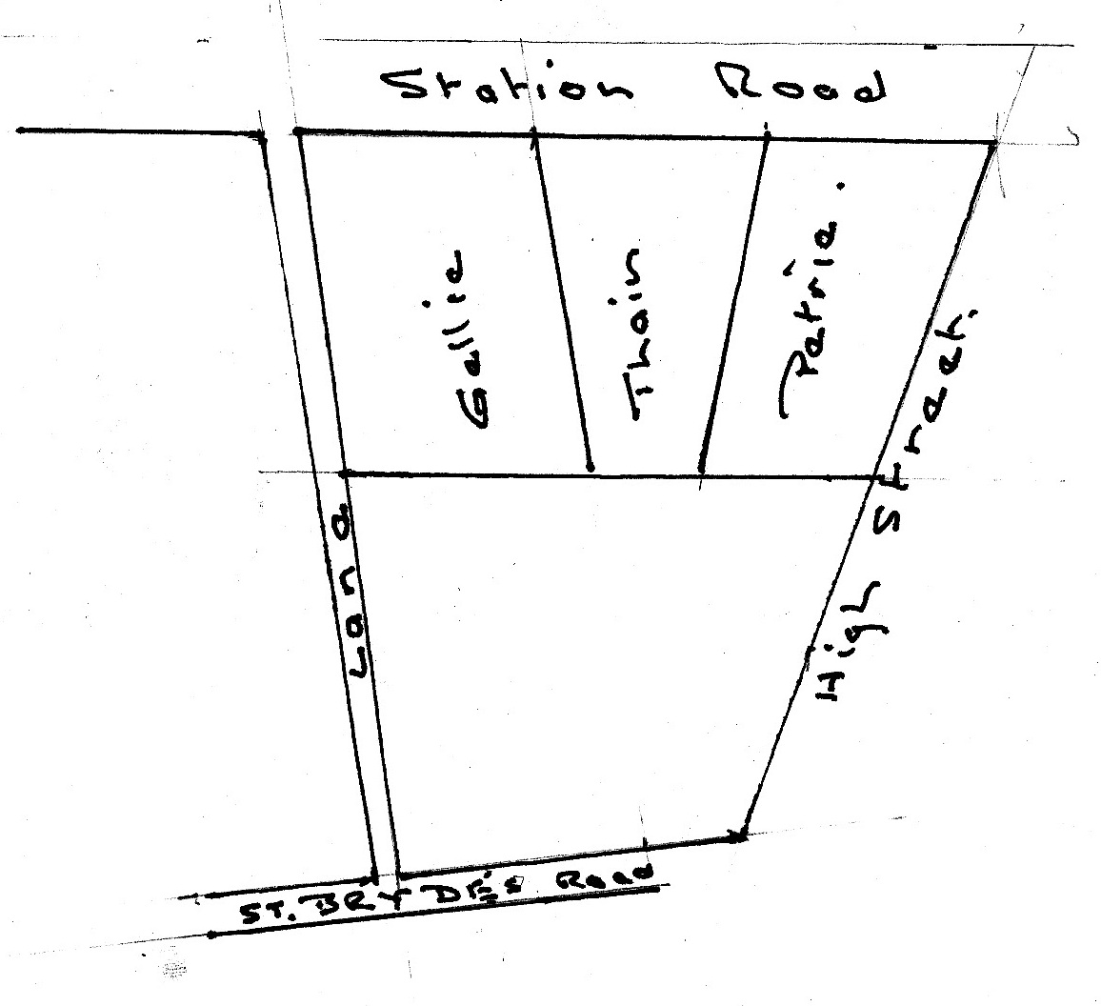
The plot between Gellie's and the High Street was originally leased by James Thain, a quarrier, who built a tenement, again in the lower corner next to Gellie, long known as The Happyland, which housed six families, which in 1881 numbered 38 people. This plot was later subdivided in 1887 when Andrew Petrie leased the part fronting on High Street and Station Road and built the large block dated 1888 which housed a department store, consisting of; hardware, drapery, gent's outfitting, grocery, ironmongery, house furnishing and a bank agency.
The portion bounded by High Street, St Bryde's Road and the lane to Station Road was originally leased by a George Emslie in 1865 who defaulted and the lease was transferred to John Davidson, who built a house in the corner next to the lane and a building fronting on to St Bryde's Road and the High Street, which housed a general merchant's shop on the ground floor.

