THE GROWTH OF THE VILLAGE
A whole generation has grown up in the village which has never seen trains passing through the village. There are far fewer who have travelled on that railway.
At the time the railway arrived, there was no village. The steading of the Mains of Kemnay stood where the chemist's shop now is, and the merchant's shop/post office was where the co-op in the square stands. The village school stood near the recently built schoolhouse – now The Old Schoolhouse.
Shortly after the arrival of the railway, the laird commissioned a development plan for the area adjacent to the railway station, part of which is depicted below.
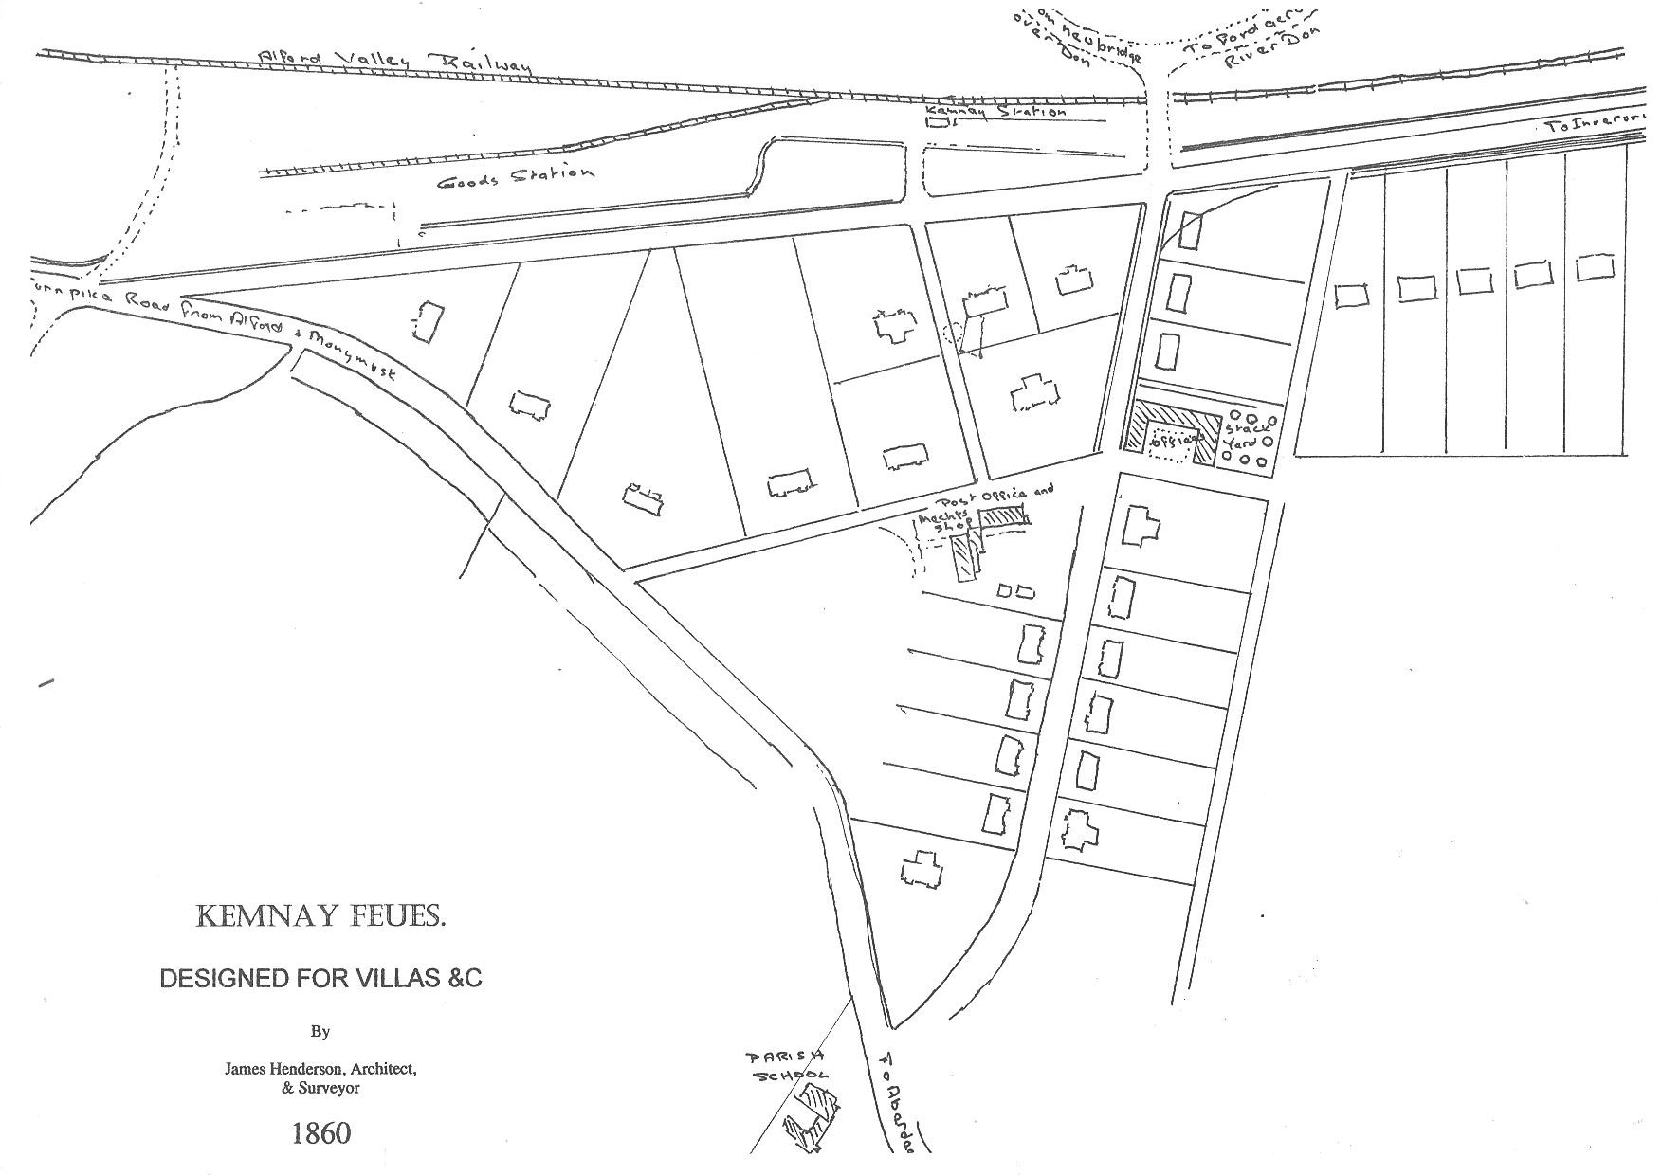
The land was to be laid out with villas for artisans, and those nearest the station were to be reserved for railway workers. The plan was based on the recently laid out Station Road, the turnpike road [Grove Road], and what is now High Street. The path of the old road from Monymusk, now St Bryde's Road and Paradise Road, is still in existence today.

