GROWTH OF THE VILLAGE, PART 2
How long the merchant's shop had been situated alongside the road from Monymusk is unknown. William Maitland had traded there since 1852 when he obtained the lease at a cost of £15 per annum. He came from Pitmachie, Old Rain [sic] and succeeded one by the name of Bisset. He served an area which was completely rural – groups of houses being situated around the farms in the area – the largest grouping of houses being at Craigearn.
When building sites began to be leased, in 1862, Maitland was the first to take up the offer and built a house adjoining his existing premises – see picture below.
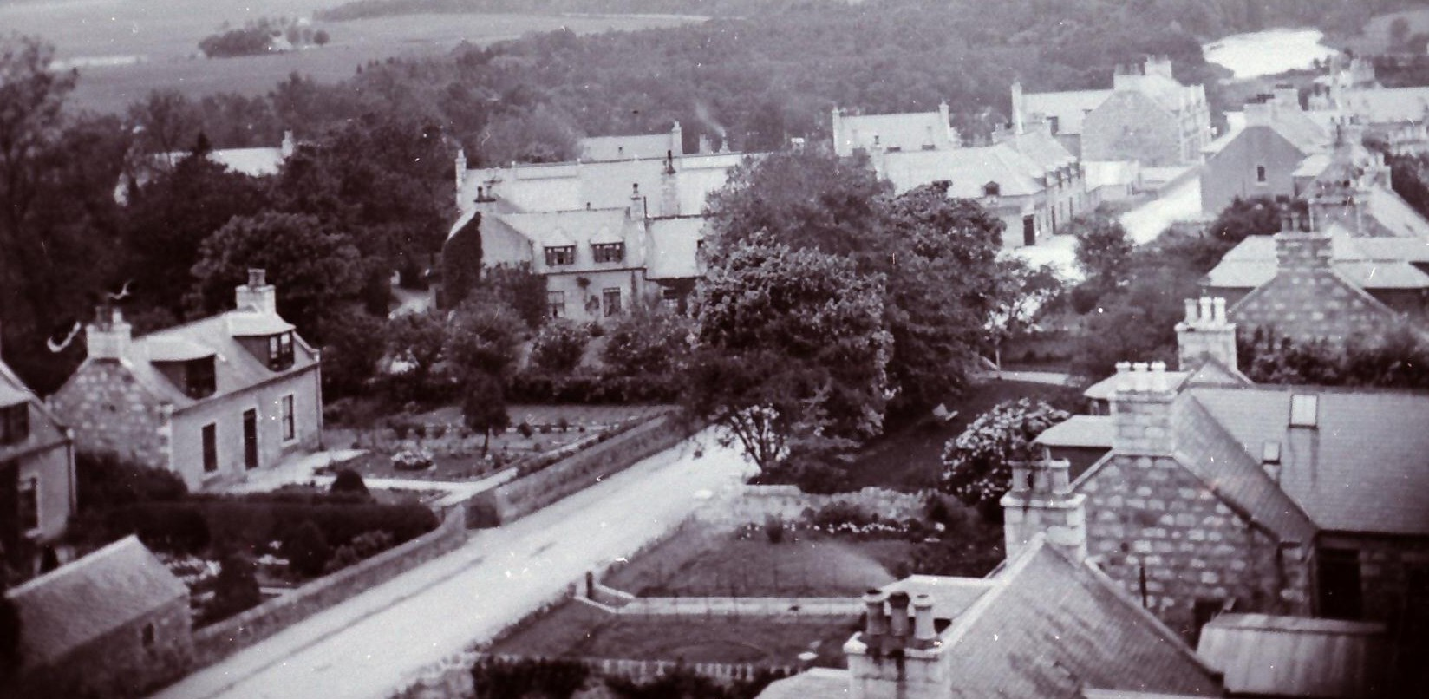
The laird's plan to lease land for villas and other superior dwellings did not come to fruition. The next plot of ground to be leased was that piece of ground on which now stands what was the Gushet Neuk. It was acquired on a 99 year lease by George Gellie, a 25 years old superintendent at the quarries, who, instead of erecting a villa in the middle of the site, proceeded to build a tenement on the corner of the site which housed up to six families. Adjacent to this he erected a commercial building (latterly housing the public bar of the Gushet Neuk) which was initially occupied by John McDonald who conducted a bakery business in the premises.
Over the years, the site was further developed by the erection of the building which now houses the Indian takeaway and the range of other buildings around the perimeter of the site.

