THE VILLAGE AND WAR 8
THEY LIE IN FOREIGN FIELDS
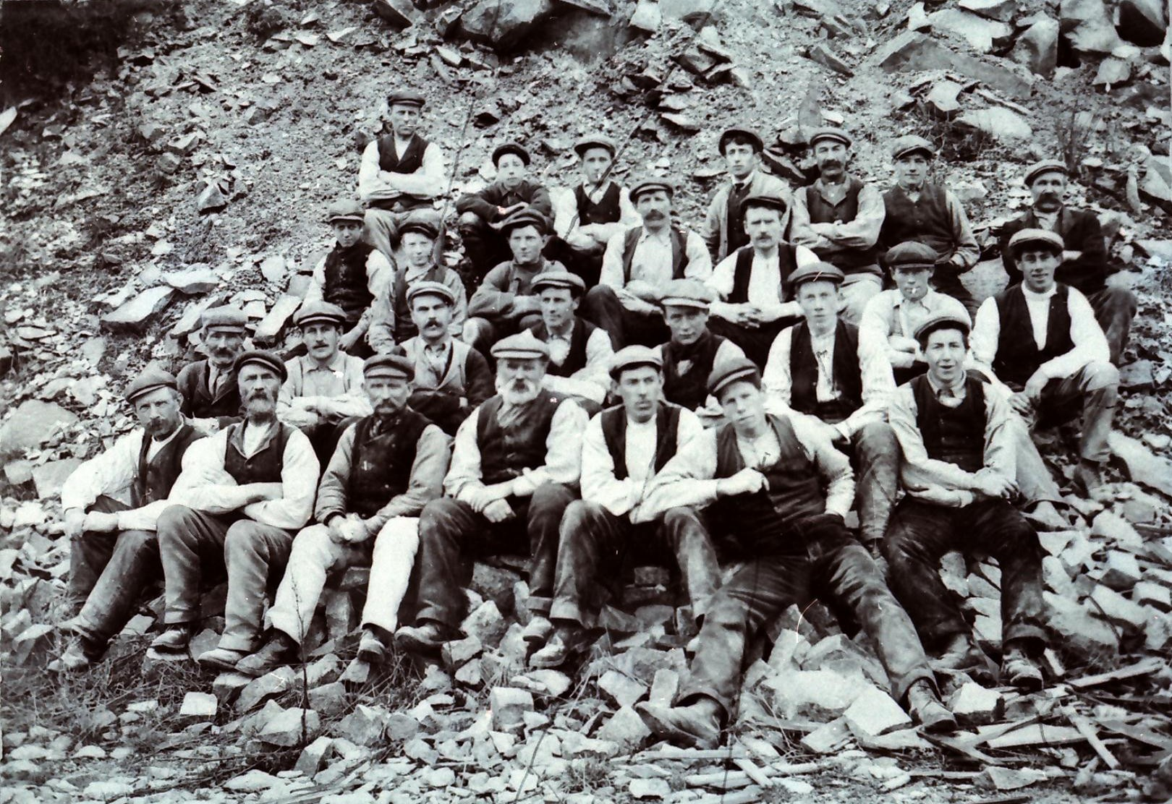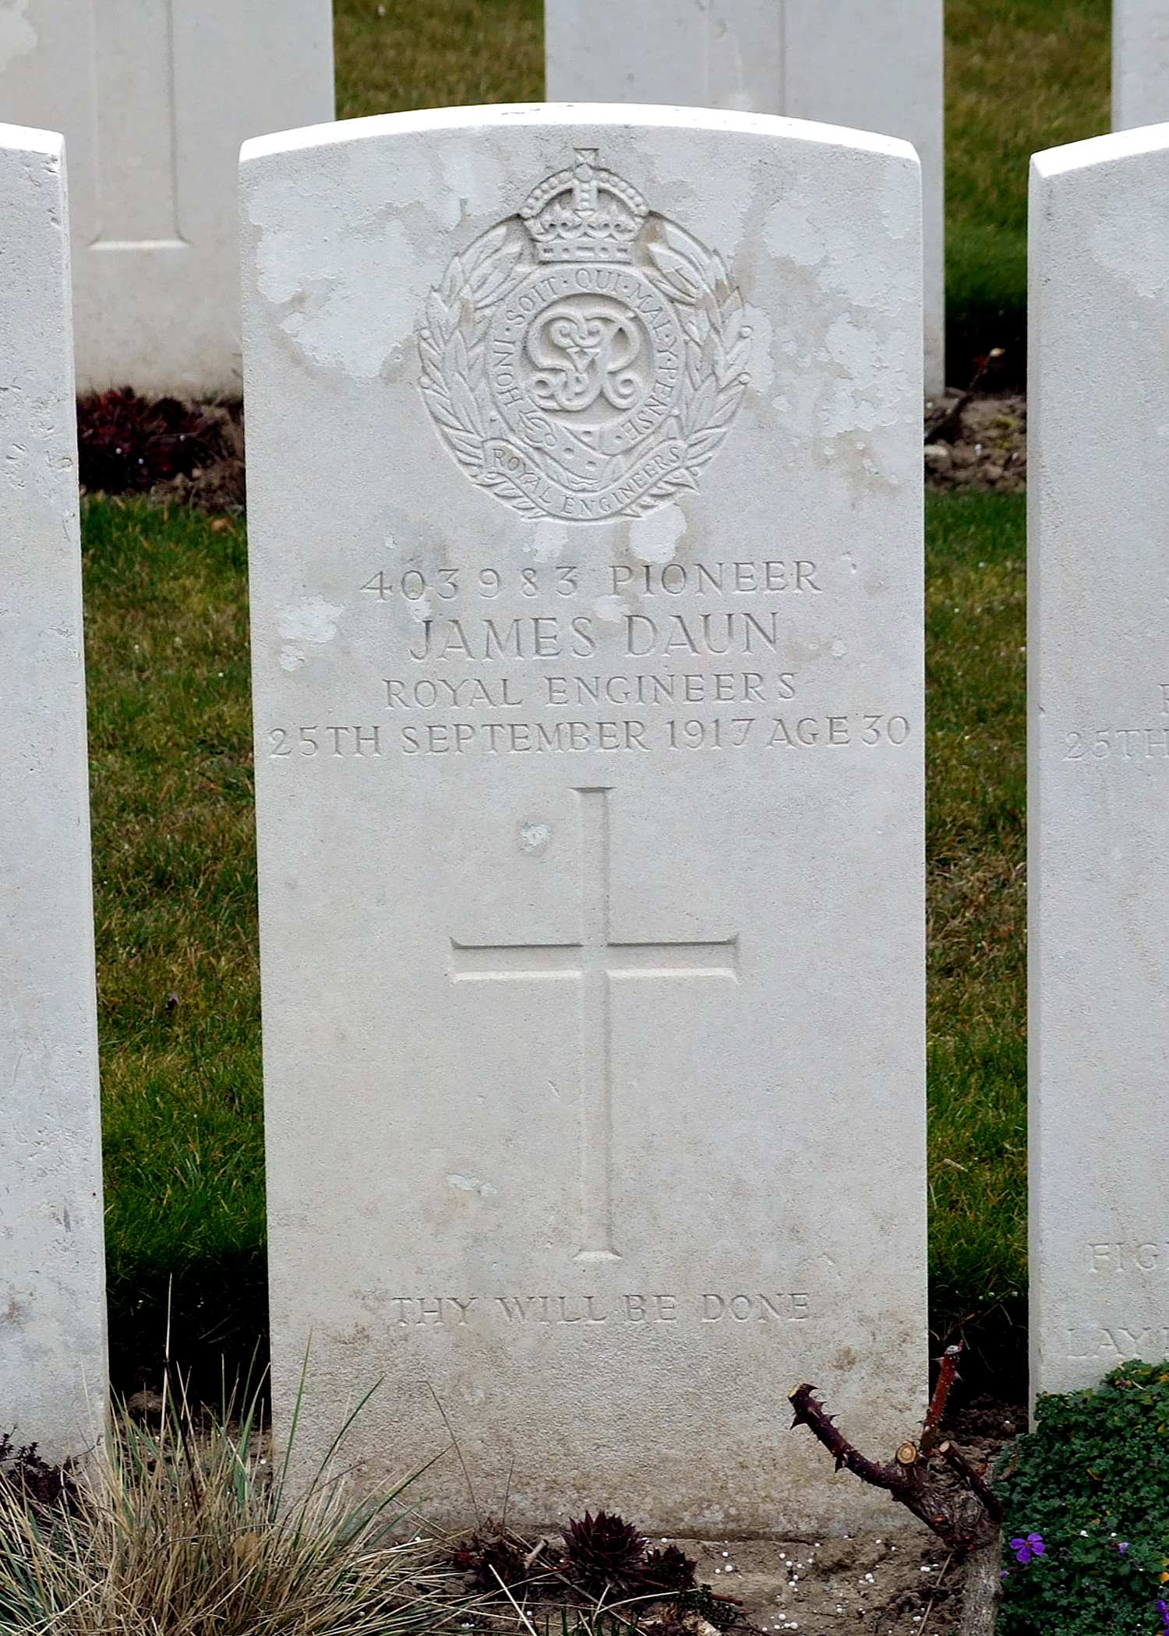
In happier times at Kemnay Quarries – James Daun is second from the right in front row. Frank Findlater (see May 2014) is second from left in second back row.
James Daun's memorial in La Clytte Cemetery.

Many images of WW1 show men in the trenches which were so important a part of that war. In fact they were home to hundreds of thousands of men throughout the conflict.
These trenches had initially to be constructed and continually maintained in order to be fit for purpose. Not only that but a massive back up system of roads and light railways had to be built to supply these men at the front with food and ammunition and to remove wounded and dead or dying casualties.
This infrastructure was the responsibility of the Royal Engineers, which by 1917 was almost 300,000 strong.
There is no doubt that his earlier training at Kemnay Quarries stood James Daun in good stead when he became a member of 319th Road Construction Company, Royal Engineers.
He was killed in action on 25th September 1917, aged 30 years, and is buried in La Clytte Military Cemetery Plot III. B. 19.

