WAR AND THE VILLAGE - 3
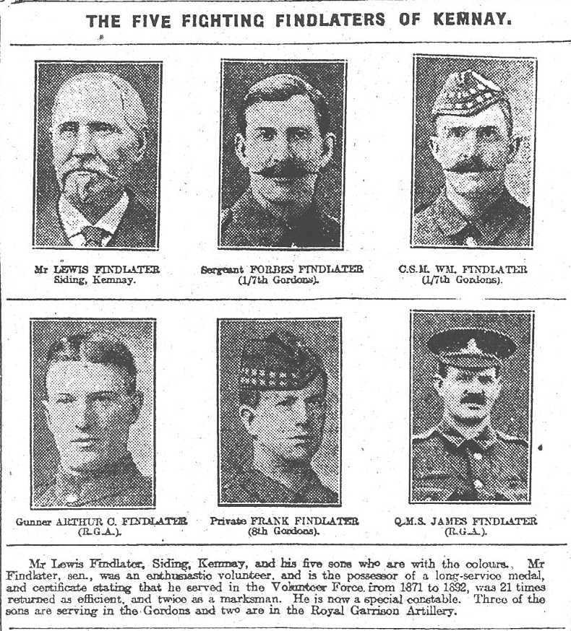
The above article appeared in the Evening Express of Monday January 17 1916 and depicts Lewis Findlater and five of his sons who were fighting at the front.
Sadly, three of the sons were killed during the war: Forbes (by then Sergeant Major) was killed on 7th July 1916 aged 43 years and is buried in Maroeuil British Cemetery in France; Francis (Lance Corporal) was killed on 28th June 1916 aged 19 years and is commemorated on the Loos Memorial in France; William (Company Sergeant Major) was killed on 23rd August 1918 aged 37 years and is buried in the family plot in Kemnay Churchyard.
Another family member buried in the family plot was Alexander who was killed at the quarry on 17th October 1908 aged 26 years.

