WAR AND THE VILLAGE 5
HE WENT ABOUT DOING GOOD
These days, the name Francis R. Gregson will mean nothing to all but a few of the more senior folk in the community. A soldier by profession, Major Gregson served in the expedition to the Soudan in 1884, in the Nile expedition in 1884-5, the campaign in the Soudan in 1898. When he returned from serving in the South African War (1899 – 1901) with the Gordon Highlanders, he was given a rousing welcome by the tenantry on his estate at Tilliefoure.
Related to the Grants of Monymusk, Francis Gregson inherited the Estate of Tilliefoure from one of that family and set up home at the Place of Tilliefoure and carried out many developments across the estate.
Wishing to get access to Kemnay Station without having to go through the village, he built Riverside House and was thus permitted to form what is now Riverside Road.
He took a keen interest in the 1st Kemnay Company of the Boys Brigade, initiating the Gregson Challenge Medal, examples of which were cast in solid silver.
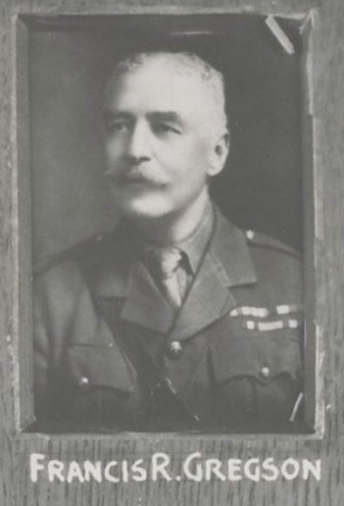
Francis Gregson campaigned for a crossing of the River Don at Monymusk. According to the Aberdeen Daily Journal of 21st November 1906 "Mr Gregson gave the handsome contribution of £2000 towards the cost, and a public subscription which he initiated raised altogether over £3000". The bridge was opened on 22nd November 1906 to great acclaim and was for many years known as the Gregson Bridge.
The outbreak of World War I saw him serving with the City of London Yeomanry (Rough Riders) 4th Battalion attached to 4th Australian Division. He was killed on 15th May 1917 aged 62 years and is buried in Mont-Huon Military Cemetery, Le Treport, France Plot 4 Row A Grave 2.
Following his death, the estate was disposed of and in September 1919 a two day sale was held to dispose of the contents of the house.

