WAR AND THE VILLAGE.
THEY RETURNED NO MORE.
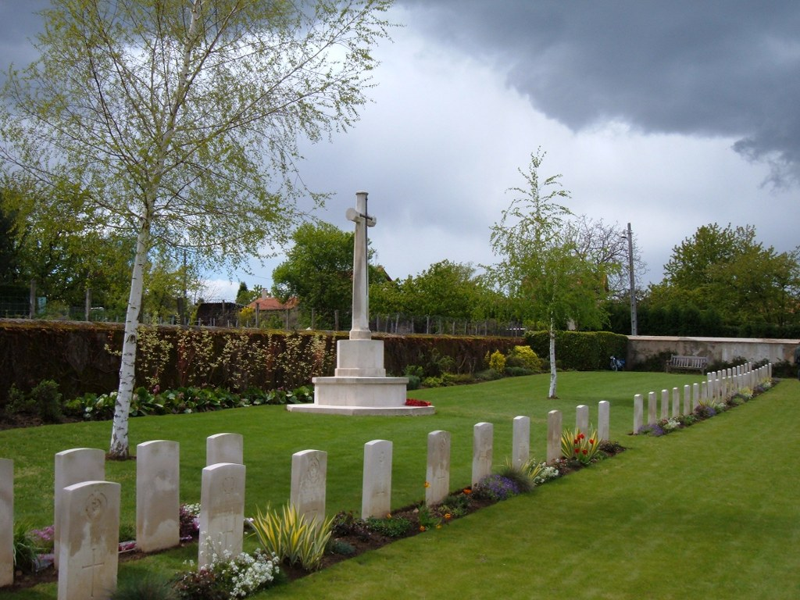
Robert Anderson Ewen was a tailor to trade and lived with his wife Isabella and their family; Robina, Albert, James, Barbara and Mary, in Kirkville (the first house on Victoria Terrace from the school end) He enlisted on 15th November 1915 at the age of 31 years and 180 days.
His unit of the 13th Battalion Royal Scots sailed for Boulogne on 7th April 1917 and reached Etaples in northern France the next day. He was posted missing on 1st August of that year and on 1st October it was ascertained that he was a prisoner of war in Limburg in Germany.
He died of influenza on 27th December 1918 and is buried in St Germain-au-Mont-d'Or Communal Cemetery Extension, Row B Grave 43. This cemetery is situated some 14.5 kilometres north of Lyon and was begun in October 1917 and used by a Rest Camp and a small British Hospital until November 1919 and lies to the west of the original cemetery. There are 116 casualties in the cemetery.
[The writer is deeply indebted to Gaenor Berkin, who stays in the village, for much of the information contained in this series of articles and compliments her on the considerable amount of research she has carried out on those who fought in WW1].

