WAR AND THE VILLAGE 6
LEGACIES OF WAR
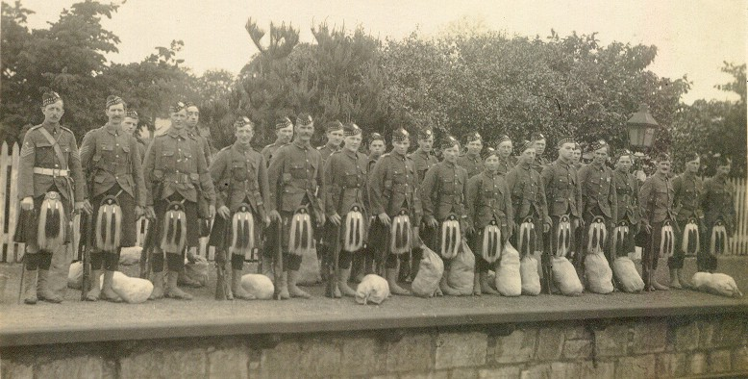
The above picture depicts a group of soldiers at Kemnay Station on their way to serve at the front. One hundred years on it is difficult to identify individual men in the picture, but, second from the left could be Forbes Findlater, while three further along in the front row could be William Henderson.
The names of those who did not return are etched in the hearts of the family members who were left behind as well as on the memorials in every parish throughout the land.
What is not recorded so publicly are those who suffered injuries of differing severity and who had to live with these injuries for the rest of their lives. Mention has already been made in these articles of Charles McLeod (Nov 2013) who took up his gratuity and invested it in a venture which collapsed, and who went idle for years before gaining employment.
Another, still remembered by the older folk of the community, was Robert Nicol (Bob), who worked as a blacksmith before the war but who lost a leg during the conflict. Unable to return to his chosen occupation he retrained as a shoemaker. He stayed in the family home at Backward and walked from there to the village.
There were many more who suffered injuries of a less severe nature and who had to live with the effects of these, both physically and mentally for the rest of their lives.

