THE FINAL JOURNEY
In times past, before the advent of the internal combustion engine, coffins were carried to the churchyard. Some communities had a purpose made bier, but more commonly coffins were carried on two poles or spokes. To prevent embarrassment of the poor, the coffins were covered by a mort cloth or pall – hence the name pall bearer – hired out by the Kirk Session. Income from this was used to help maintain the poor in times of need.
With the advent of motor vehicles, hearses were constructed by simply fixing the body of a horse hearse on the chassis of a lorry or suchlike. As vehicle body building developed hearses as we know them today gradually evolved.
The death occurred recently of Robbie Allan, originally from Garlogie, who had been involved with motor bikes in all shapes and forms for more than 50 years. In 2007, at the age of 65, he took part in the Dakar Rally, a gruelling fifteen day endurance test from Lisbon in Portugal, down the west coast, east to Malaga in Spain from where they crossed to North Africa and carried on through the desert to Dakar in Senegal a total distance of around 5000 miles. Unfortunately, due to mechanical failure of his bike, Robbie had to withdraw after 3000 miles.
He was diagnosed with cancer earlier this year and died at home on 14th August 2013. A celebration of his life was held at a motor bike circuit near Biggar, in which Robbie was deeply involved, on Monday 19th August and the family journeyed north the following day for a committal service in Kintore Cemetery which was attended by well over 100 people from all airts.
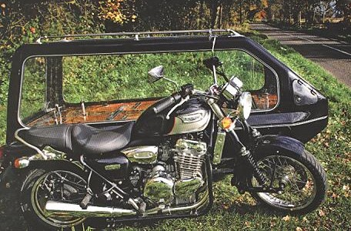
The cortege arrived at the Cemetery led by the bike which took part in the Dakar Rally, ridden by Robbie's brother Vic, followed by Robbie in a motor bike hearse with his wife Margaret riding pillion behind Rev Paul Sinclair, who led the service and is the owner of Motorcycle Funerals which has been in existence for eleven years.
Following the service the hearse was parked outside the writer's premises and it certainly turned a few heads.

