REUNITED AT LAST
Annie Fraser, second daughter of William Fraser and Jane Bain, married John Cameron who worked as a hotel boots in Glasgow. He developed heart disease followed by pulmonary tuberculosis and died at Backward, Kemnay on 3 April 1905 and was buried in Kemnay Churchyard. On 20th December 1912 Annie married Alexander Reid, farmer, at John's Forest Kintore. They had two of a family, Alexander Burr Reid, who was lost in action near St Valery in June 1940, and Catherine Ann Reid who was later to marry Gordon Robert Ingram.
James Fraser, a boots at the Kenilworth Hotel in Glasgow, married Catherine Livingstone, a housekeeper from Ardluie near Loch Lomond, at the Temperance Hotel, Kemnay on 18th April 1913. They settled in Glasserton Road in Glasgow where they brought up their two sons, Bill and Archie. Bill died shortly after WW2 from cancer and Archie married and settled down in Oban.
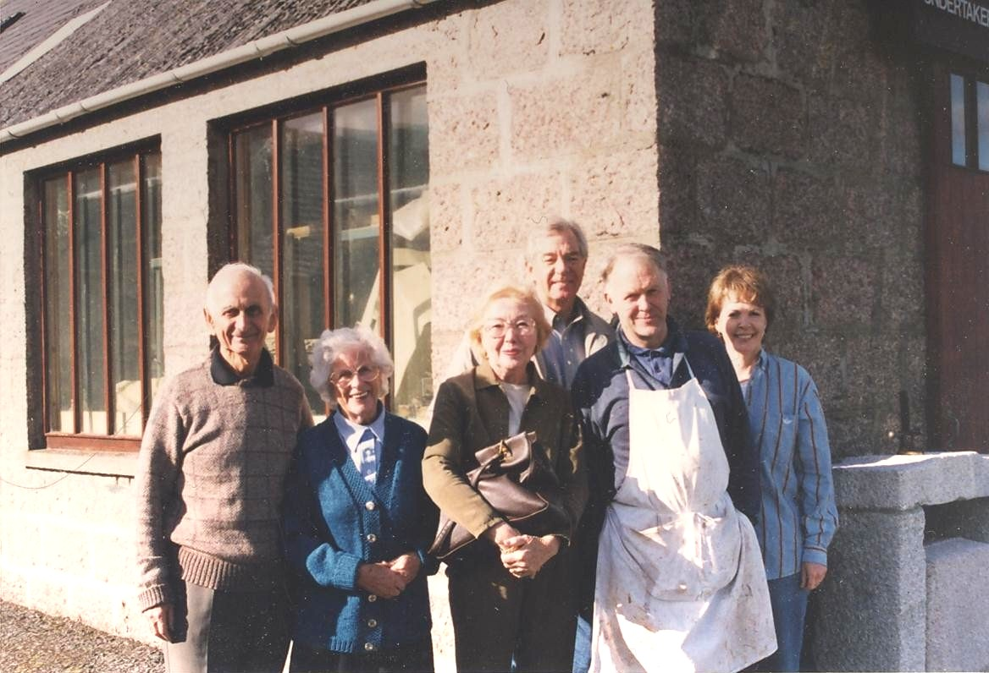
Over the years the American Frasers lost contact with their Kemnay cousins although visits were occasionally made to the Woods – George's wife's family, some of whom stayed in Aberdeen. On one such trip in August 1998, Jim McDougall, his wife Joy and Jim's sister Jan, grandchildren of George and Janet Fraser, visited the churchyard at Kemnay and were pointed to the family gravestone by a local lady who later informed the writer about who she had met. Gordon and Cathie Ingram were alerted to the presence of the long lost cousins and they made contact with them at their hotel in Aberdeen only to learn that it was the party's second last day in the area. The following morning the Americans met up with the Ingrams and returned to Kemnay to meet up with the writer to express their grateful thanks for arranging the meeting of two branches of their family after a space of ninety years.
L to r: Gordon Ingram, Cathie Ingram, Jan Smith, Jim McDougall, Duncan Downie, Joy McDougall
Since then most of the cousins have visited from America and made contact with their Scottish relatives but sadly both the Ingrams have passed on, one of their regrets being that by the time the cousins had found them, they were too old to travel to America.

