SCOTLAND'S BIGGEST EXPORT
Over the centuries one of Scotland's greatest exports has been manpower. Some of this was voluntary, sometimes it was compulsory (witness the clearances). Let us try and follow the fortunes, or otherwise, of one family who stayed at Backward, fully a mile from the village on the way to Inverurie.
William Fraser, a quarrier and crofter of 5 acres, was born in Kintore in 1842. He married Jane Bain (b. 1843) at Glenhead on 29th May 1864. They produced: Jane (b. 1865), William (b. 1867), Alexander (b. 1869), George (b. 1871), Annie (b. 1875), James (b. 1877), Donald (b. 1877), Charles (b. 1881), and Robert (b. 1884).
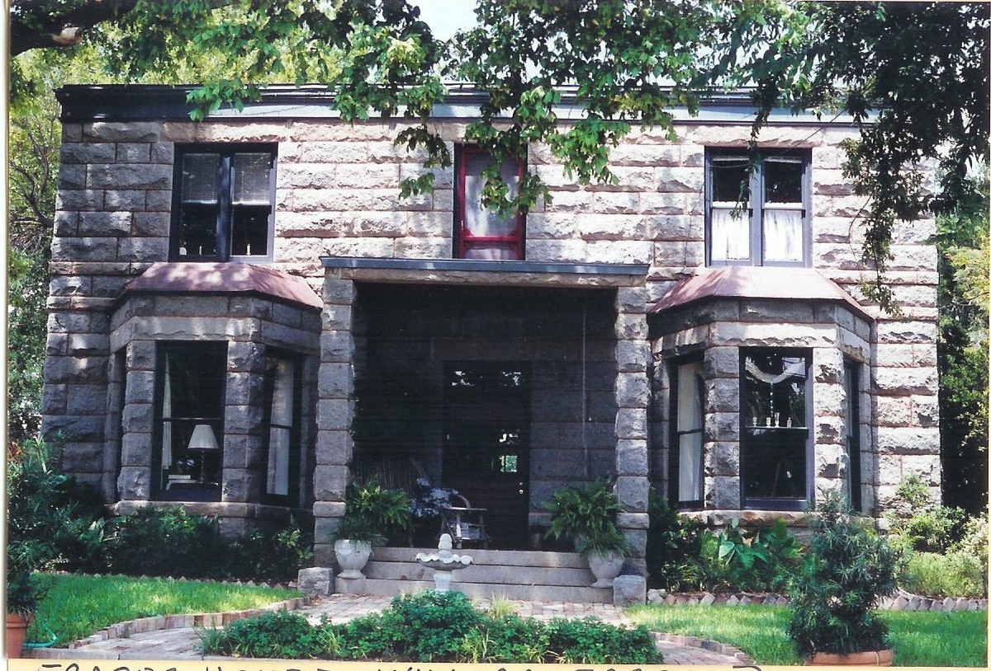
It was in no way possible to support that many people on a small north east croft so it was inevitable that most of them had to go forth and make their livelihood elsewhere. Jane, the eldest, emigrated to America where she settled down and married, staying in Michigan and Massachusetts. William was one of 23 Scottish master stone cutters invited to America in 1888 to help to complete the building of the State Capitol Building in Austin, Texas. William is credited with erecting the first granite dwelling house in Llano around 1900 (see left) in an area where most buildings were constructed from wood. He returned to Scotland and encouraged his brothers Alexander and George to return with him where they opened a granite quarry near Llano. They were soon followed by Donald, Charles and their families. Robert, the youngest crossed to America in 1913 but sadly contracted an illness on the boat from which he died and was buried in Brooklyn, NY.
Annie married John Cameron who worked for several years in Glasgow before developing heart disease and died at Backward on 3rd April 1905. Annie later married Alexander Reid at John's Forest, Kintore on 20th December 1905. Sadly he died on 28th March 1924 aged 57 years. Annie herself died on 12th April 1955 aged 80 years.
James married Cathryn Livingstone and stayed for some time in Glasserton Road, Glasgow, where their two sons, Bill and Archie lived out their formative years.

