STORMY TIMES
During the 1950s there were several bouts of quite stormy weather. One such period was at the beginning of February 1958, when, on Saturday 8th February there were two funerals from Kemnay Parish Church. In the morning, Mrs Annie Webster, wife of David Webster, who stayed in Alexandria Cottage, Paradise Road was buried quite near the church gate. Annie was the youngest child of Robert Riddler, a granite stonecutter, and his wife Margaret Milne. The family stayed at Thain's House (Happyland), the building in Station Road, now partly occupied by the Chinese takeaway.
In the afternoon the funeral of John Adam, Sunnybrae took place. Some of our older readers will remember John who was a mason in the village and it was he who built most of the houses in Riverside Road. He stayed latterly in Sunnybrae, which he had converted in the 1930s from the stables of Gowanbank.
The weather had been somewhat middling for a day or two earlier in the week and the council had said they would try and keep the Craigearn Road open for the funeral. This road was then completely different from the present layout. The roadway was narrower than at present with dykes at both sides which, when the wind was from a certain direction, caused the snow to fill the road rather quickly. Conditions during the forenoon deteriorated considerably and the council had to give up the struggle to keep the road clear. They opted instead to try and keep the road round by Meadowbrae to Cluny Crossroads open.
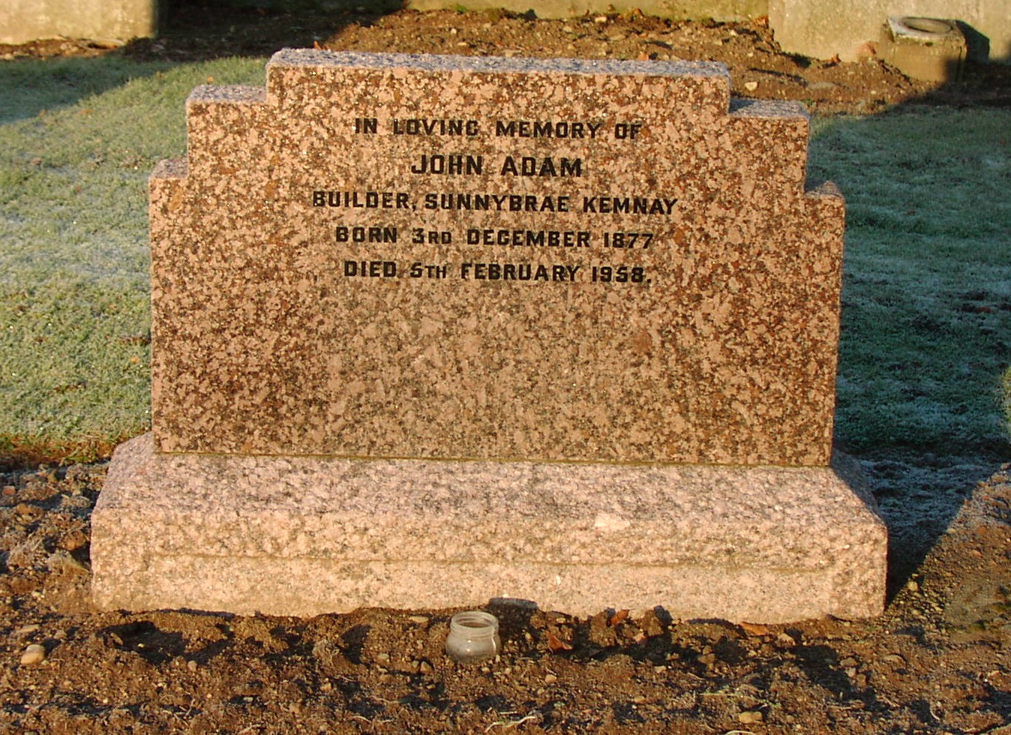
Following the funeral service in the church the cortege set off for Cluny, preceded by the snowplough. Just before the bridge over the Burn of Ton, the hearse gave up the ghost and refused to go any further. It was some time before the snowplough gathered there were no vehicles following and it reversed from Bridgefoot to see what the problem was. As it was clear that the hearse was going nowhere fast, the coffin was transferred from the hearse into the back of the snowplough lorry and was accompanied on its journey by Grant Downie, the undertaker. The cortege arrived at Cluny Churchyard without further mishap.

