A FAMILY LEAVES
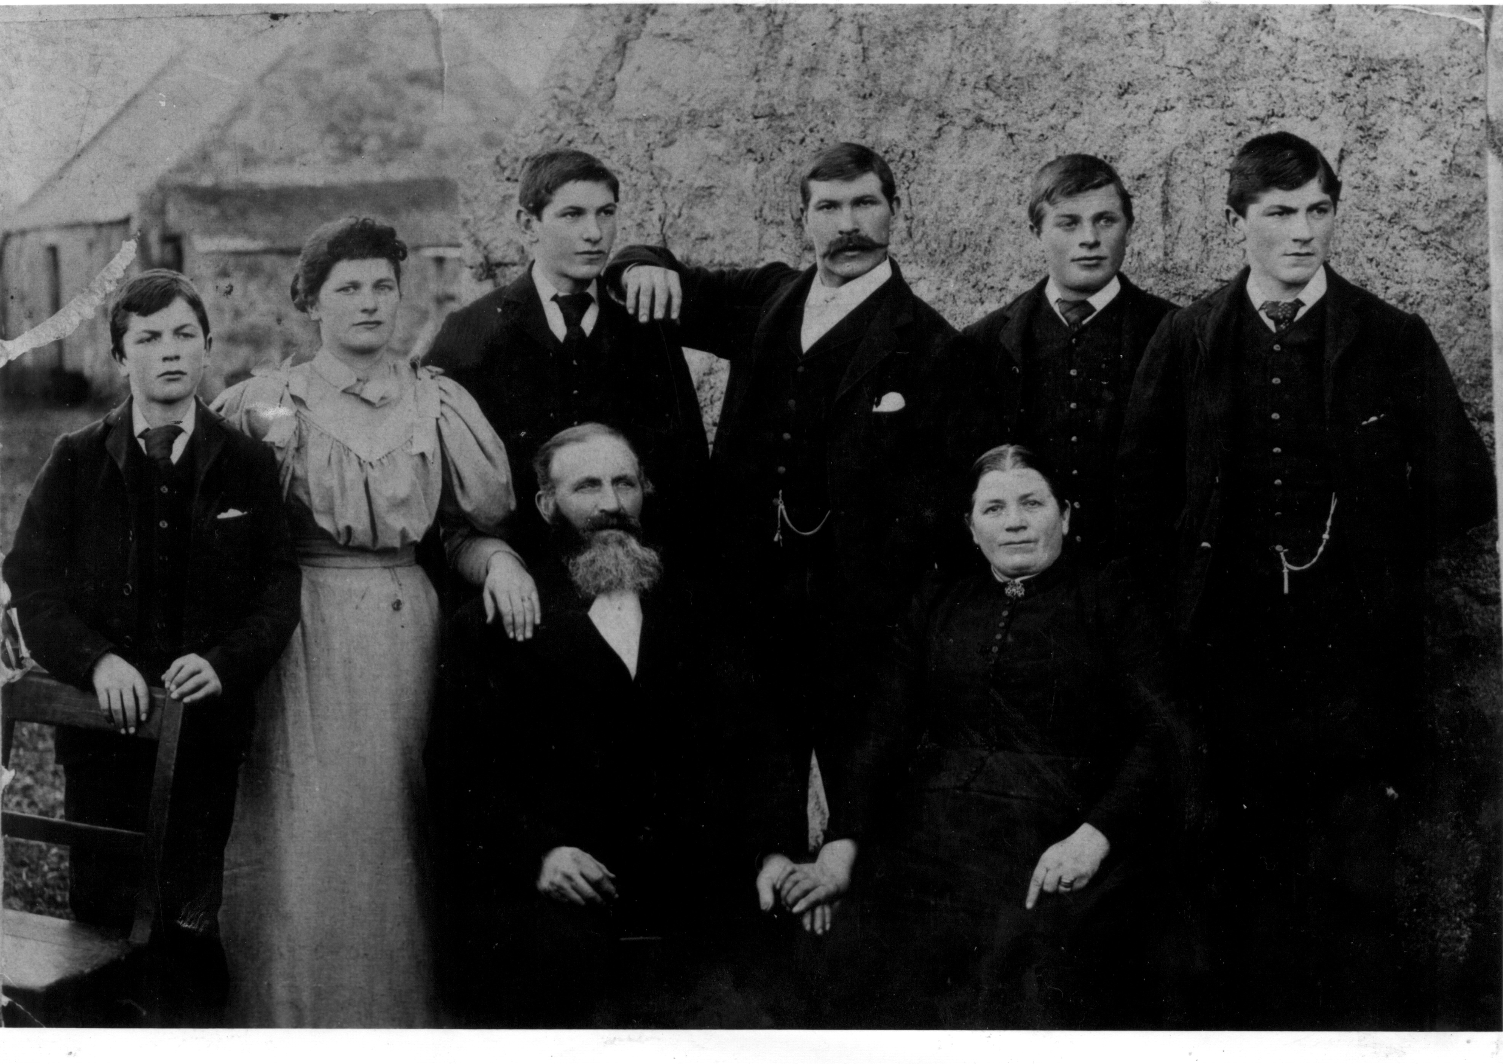
William Fraser persuaded four of his brothers to join him in America to engage in the then booming granite trade. Initially they quarried at Llano, a small city (so called by the Americans) which lies about 75 miles north west of Austin, which in 2010 had a population of 3232 (slightly less than the population of Kemnay). William, as mentioned in last month's article, built the first granite house in the town and it is still in existence today operating as a bed and breakfast under the name of Fraser House. William married Laura Griffin but they had no family and he died in 1917. Alexander didn't marry but developed stone cutter's consumption (T.B.) and died in 1914. Donald's wife Hannah died shortly after the birth of their second son and he moved to Boston, Mass. with the two boys to start a new life.
George Fraser and his wife Janet Woods went to Llano in 1907 with their eldest children George and William; Helen and Leslie were born after they settled in Texas. George followed his father into the granite trade while William entered the construction trade and worked for Brown and Root.
The Fraser family at Backward, Kemnay
Charles Fraser had gone to Llano with his brother George in 1907 and his wife Robertina Mitchell, a Kemnay lass, joined them in 1908 with two daughters Jean and Evelyn. A further four children were born in America. Charles worked in the quarry at Llano until 1930 when he moved to Marble Falls, which lies some 45 miles north west of Austin, to work in the quarries at Granite Mountain (see image below) owned at that time by Texas Pink Granite Corporation. The corporation was bought over by Cold Spring Granite Company from Minnesota who are still operating there in a big way.
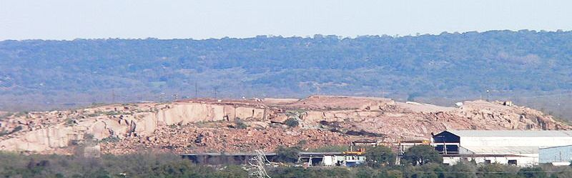
Charles suffered an injury and when he recovered, he and his wife went in to the restaurant trade but sadly Charles was killed in a motor accident in 1946. Robertina was then joined by her son Jack until she retired due to ill health.

