SHANKS' PONY
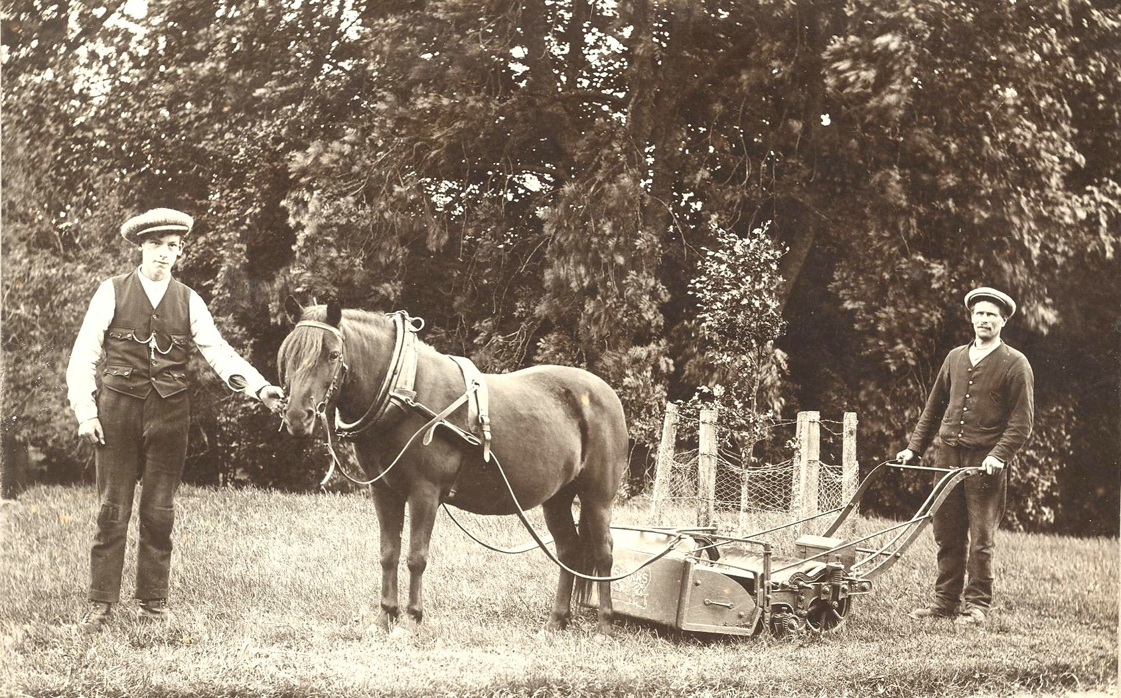
The above photograph was received from a friend recently and was captioned "Fetternear Gardens". There is nothing further to identify the people in the photo or the time but it is thought to predate 1930.
The mower was manufactured by Alexander Shanks and Co. of Arbroath which can be ascertained from the logo on the box behind the pony's hind legs. Shanks started the manufacture of mowers in the mid nineteenth century and they became popular for keeping golf courses and large lawns as on estates. In better class establishments it was not unknown for the pony to be fitted with leather boots to prevent marking the lawns.
Most people will be acquainted with the term "Shanks' pony" which the Oxford Dictionary gives for a meaning "to use one's own legs as a means of conveyance". The Old Lawnmower Club believes that the term could have been derived from the fact that the man had a pony but still had to walk.
One thing that is not in doubt is that grass cutting and maintenance has come a long way in the intervening years.

