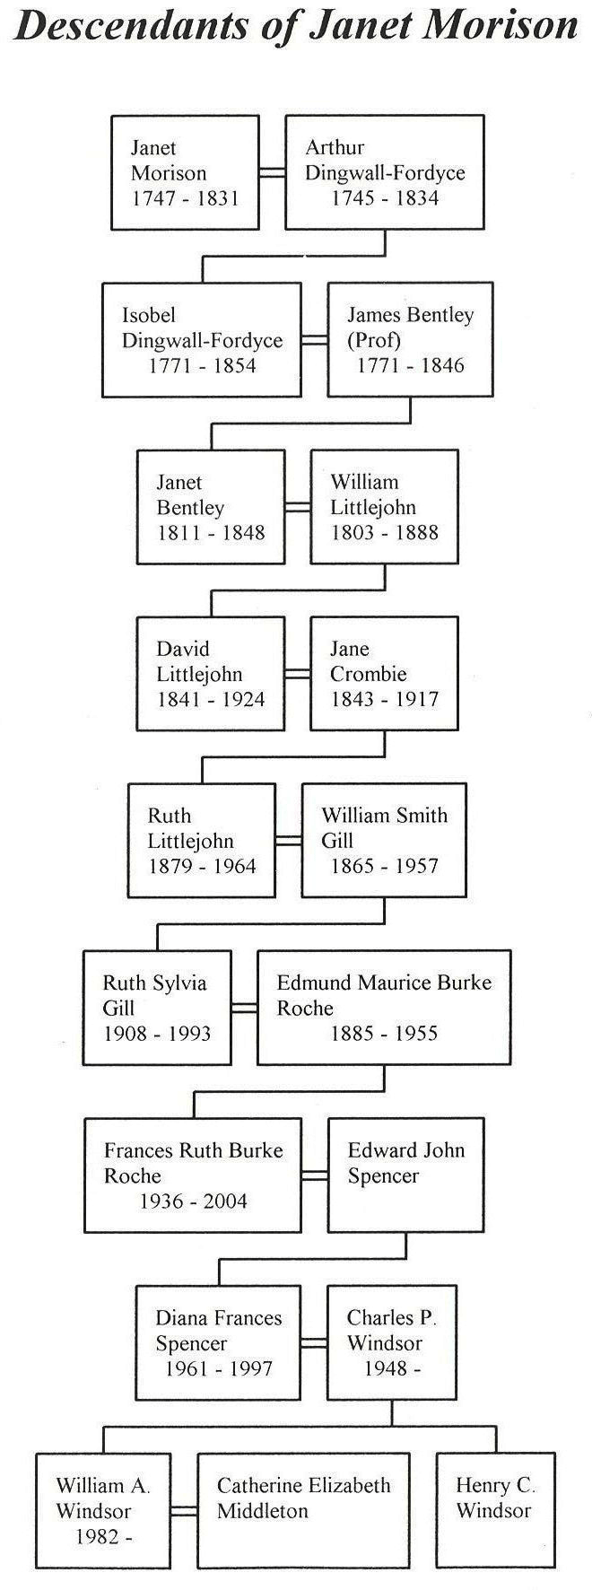
ROYAL CONNECTIONS?
Researches at Kemnay House have recently been centred on the life and times of George Burnett. Regular readers of these articles will recollect that he was the third Burnett Laird at Kemnay and it was he who started agricultural developments in the area, for which he never really received due credit. His second wife was Janet Dyce of Disblair, a small estate between Newmachar and Fintray. She is remembered for the diary she kept over many years and gives considerable details about the crops grown at the time, both in the fields and in the garden, as also reports on the weather conditions then prevailing. It was published some years ago under the title "More Frost and Snow".
Some random entries provide interesting reading: on 3rd May 1779 some 3½" of snow fell and that morning the gardener filled the ice house at the top of the hill [there was an ice house more or less on the site of "Greenkirtles"]. On 20th July of that year she notes "We opened oor Ice House that we filld the 3d of May & found the Snow much in the same state as when we put in, but it froze the cream very well".
Janet Dyce's father was a merchant in Old Aberdeen; he is buried in Old Machar Churchyard and the gravestone relates that Janet "was interred in the family burial place in the Church of Kemnay".
Janet had no family, but her sister Isabel married James Morison of Elsick in Kincardine, who was for a time Chief Magistrate in Aberdeen. They had a daughter, Janet, who married Arthur Dingwall-Fordyce of Brucklay Castle near Maud. The internet-derived chart shows the family line down to Prince William and Catherine Middleton.

