FITBA CRAZY
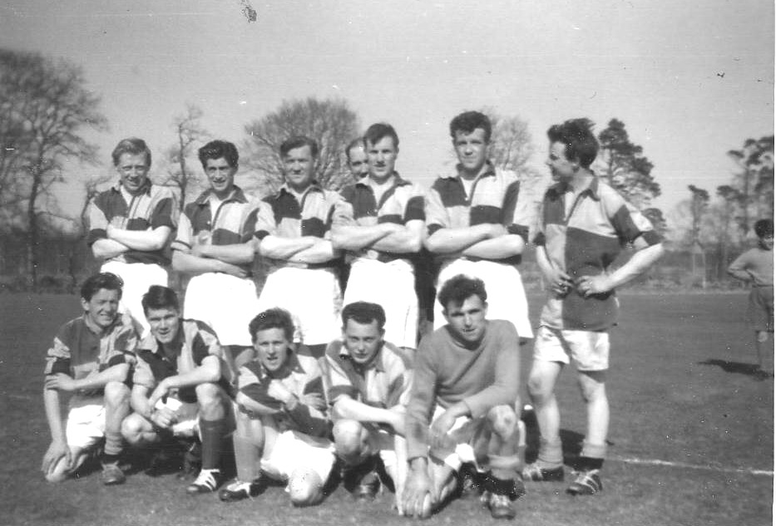
The above picture was received recently from James Dow, and as the writer had no involvement with football, he has had to glean his information from others in the community. The photo would date from around 1958 and features: back row from left; Jack Murray, John Rae, Jim Bremner, blank, Bob Barclay, Stanley Gray, Ernie Forbes. Front row from left; Sandy McCombie, Eddie Sinclair, Bill Fraser, James Dow, Bert Beattie.
The team played in the Donside League which had been formed in 1931 to give those involved in the retail trade – shop assistants etc – who worked on Saturday afternoons the opportunity to play football – matches were played on Wednesday evenings. This timing was also suitable for agricultural workers. The teams which made up the league were: Rhynie, Alford, Keig, Lumsden, Kennethmont, Strathdon, Premnay, Insch, Monymusk, Oyne, Kemnay, Blairdaff, Pitcaple, Rothienorman. Following the return of men from war service, the league was split into two divisions – North and South – this situation continued for some six years and in 1951 reverted to the original set up.
For some reason, now lost in the mists of time, Kemnay was suspended from the league during the 1953 season but was reinstated in 1954. In 1957 Kemnay won the Consolation cup and in 1959 they won the Souter Cup, which had been presented by the well known family of that name from Insch.
The League wound up during the 1960s.

