THE RAVAGES OF WAR
Kemnay is one of these communities that have not one but two memorials commemorating those who gave their lives in the First World War. The reason for this has long ago been lost, but the memorial placed in what is now Kemnay Primary School has a photograph of 60 men and one woman who died as a result of that terrible conflict. No photograph was available for J. A. Lewis Durno. The keen eyed will have noticed that there are 65 names on the memorial beside Littlewood Court – but that is another story.
The generation that is all but gone held this memorial deeply in their hearts – in fact the writer's father never passed through the school hall without stopping at the memorial, but then again, many of them were of his acquaintance and one had been his teacher at the school.
It is of the one lady that the writer wishes to think about. For more than twenty years he has tried to trace what happened to her – the Commonwealth War Graves Commission hold no records for her. Earlier this year a query arrived from Anthony Murphy in Brighton, enquiring if Margaret was buried in the family grave in Kemnay, Anthony has a personal interest in females who were killed or died whilst in service. His previous research showed that Margaret I.K. Durno, VAD, British Red Cross Society, died 14th September 1918 whilst serving at the Brook War Hospital, Kidbrooke, Kent (now Greater London). She died as a result of the Influenza epidemic but due to the cause of her death and status she did not come within the criteria of the Commonwealth War Graves Commission for commemoration in the Debt of Honour Register.
Having found out that Margaret had not been buried in the family grave at Kemnay, Anthony continued his researches and eventually discovered that Margaret had been buried in an unmarked grave in Greenwich Cemetery in London.
Several generations of Durnos farmed at Leschangie, Kemnay from the mid 19th century onwards. One, Alexander, married Barbara Mortimer and three of their family, James A Lewis and twins Margaret and Leslie were all killed during the First World War. Lewis served with the 6th Bn. Gordon Highlanders and died on 13th November 1916 aged 22 years – he is buried in Forceville Communal Cemetery, Extn, France. Leslie served with the 4th Bn. Seaforth Higlanders and died on 20th July 1918 aged 19 – he is commemorated on the Soissons Memorial in France. There was a younger daughter Rosalie. Following Alexander's death in October 1913, Barbara moved to the Blairdaff area. As well as being commemorated on the memorials at Kemnay, The Durnos also appear on the memorials at Blairdaff and Monymusk.

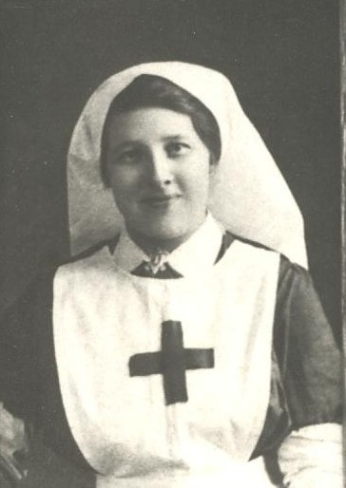
Margaret I. K. Durno

