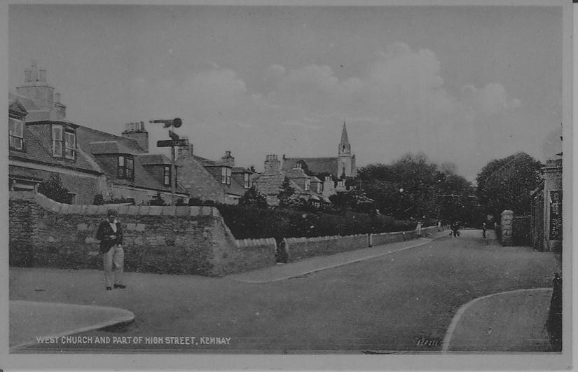
This month's photo dates from between mid 1929 and the end of 1934. One may ask how the picture can be dated so precisely. In May 1929 the historic decision was taken for the United Free Church of Scotland and the Established Church of Scotland to unite. For some reason or another, the good folks of Kemnay could not agree to a union and they decided to keep going as two separate parishes under the names of East Church for the church on Fraser Place and West Church for the former Free Church on top of the hill. After several failed attempts, a union was agreed on January 1 1935.
The picture is taken from about the outside of what is now Ross the baker's shop door and the keen eyed will see at the bottom right had corner of the picture the railings in front of the gardens of what was then dwelling houses. Looking farther up the street a granite pillar will be seen just beyond what is now Kellas the solicitors' office. This was the side entrance to Gordon the grocer's premises and led to the van shed and stables. High Street was widened in the second half of the 1930s back to the line of the building and the side gate facing the photographer was thus removed. The widening of the street could only be done partially as the steadings at Birchfield were built on the boundary of the feu, consequentially only the part of the street belonging to Gordon was widened, possibly around 1937 when Veydon was built. As a point of interest, the other side of the street was widened to form the pavement in the early years of the century.
A wee follow on from last month's article. The observant pedestrians on Station Road will have noticed that two of the ventilators below the windows are recessed. This was used by the village policeman as he made his nightly rounds. He used the recess as a step to enable him to see that all within the office was shipshape.

