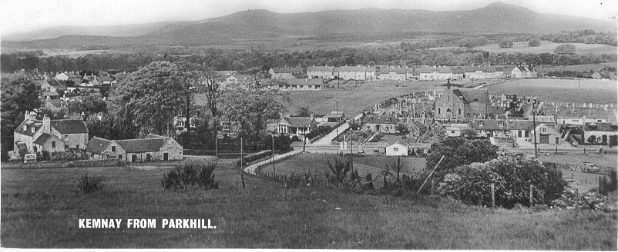
One of the biggest changes in the post-war village was the growth of local authority housing. In the period since the picture in last month's article was taken, the housing on Cairn Road had been completed by 1953 along with the two blocks on Fraser Place. Outwith the picture, the houses on Bennachie View had been built between 1954 and 1958; those on Burnett Road had been laid out in the early 1960s as well as part of Gordon Road.
Fraser Place, the lower end of which can be seen between Tornahaish and the Smiddy house was still the original fifteen feet wide as it was laid out in 1907. Beyond the church gate it was little more than a track some eight feet wide and was graded rather differently from the present day – near the top of the churchyard it was some four feet higher than at present, as will be seen by the embankment up to the churchyard dyke. Beyond this it dipped some ten feet which had to be made up when Gordon Road was formed and near the entrance to the square of houses on Fraser Place the level had to be dropped around two feet. This realigning took place around 1965 when part of the garden of Tornahaish was taken to allow for the widening at that end.
Many people who walk up and down Parkhill may wonder at the high portion of wall (shown covered with ivy in the right foreground of the picture). In the days before bathrooms were prevalent the minister's toilet facilities (a dry laavie) were situated on the Parkhill side of the steading. Not wishing the good folks of the hill to see his every move about his daily business he commissioned the wall to be built in order that he might enjoy a little privacy.
It will also be noted that petrol pumps have been installed at the garage – prior to this there were two pumps, one on either side of the garage door, which were hand operated. Cars had to reverse off the road in order to have their tanks filled, but then traffic on the road was not as numerous then as it is now.

