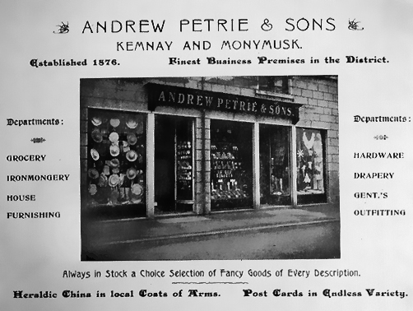
The above photo is a follow on from last month's and shows the High Street elevation of Petrie's shop along with a note all the different departments.
Andrew Petrie retired around 1905 and the business was carried on by three of his sons. Samuel Petrie, 'Buster's' father died suddenly in January 1927 and this virtually closed the business. The North of Scotland Bank acquired the property and various alterations were carried out. The small shop to the left of the picture was taken on by Sam's widow, Margaret, and run as a newsagent; the remainder of the High Street frontage, comprising the main entrance and two display windows was tenanted for many year by Alexander S. Weir, chemist, who, up until then had occupied what is now the front shop of Lingard the butcher across the road.
Further alterations took place in the early 1950s to give the High Street frontage as we know it today. Mrs Petrie had retired and her place was taken by James C. Pickford who eventually moved into what is now the hair shop across the road. The chemist, by this time William A. Sutherland – who had married Weir's daughter Connie – then moved into the smaller shop and the new frontage was constructed making the door to the bank house opening on to the High Street and forming two houses upstairs – one for the bank manager and one for the accountant. The accountant's house door was the entrance on Station Road, until recently occupied by the Clydesdale Bank cash machine.

