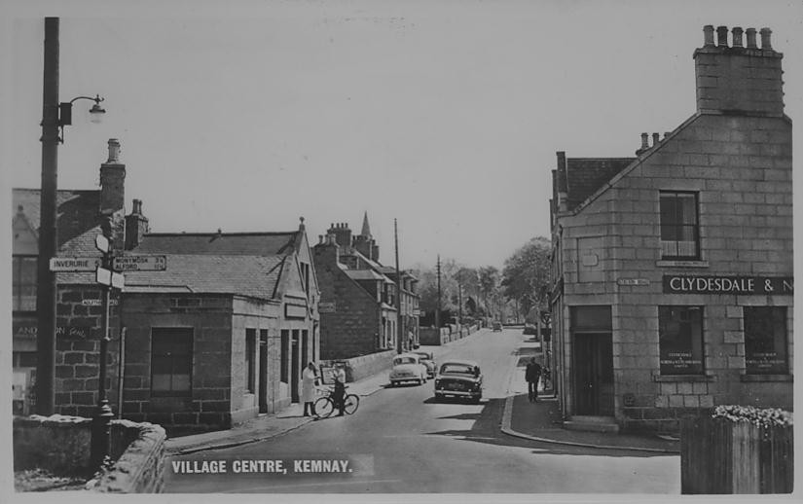

The above picture featured recently on the online auction site e-bay.
It was taken from near the bridge over the railway looking up High Street in the early 1960s. The white coated figure standing on the pavement to the left is Bob Yeats, who for long occupied the butcher’s shop behind him. Alan Chalmers is the figure with the message bike and the figure in the shadow of the bank building is Robert H Petrie (Buster), who at that time had his electrician/radio and TV Shop, where the health centre is now. The bank building was erected in 1888, as will be seen from the plaque in the recess above the bank door, by Andrew Petrie – Buster’s grandfather- as a general merchant’s shop, with the bank agency, originally Town and County Bank, on the corner. This bank integrated with another Aberdeen Bank – the North of Scotland Bank – in 1907, which in turn merged with the Clydesdale Bank, both part of the Midland Bank Group in 1950. The “North of Scotland” name was dropped in 1963 and in 1987 the Clydesdale Bank was sold to National Australia Bank Group. The bank office in Kemnay finally closed in 2005.
Another relic from the past is the post on which the road signs are fixed. This is the stem of one of the original lamp posts in the village which were powered by acetylene gas. There were seven lamps stretching from Finnercy to the quarry.

