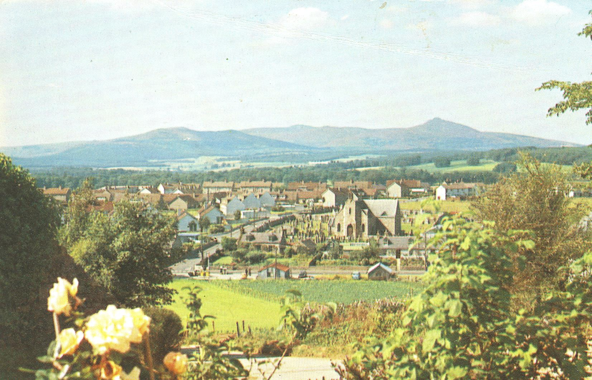
The above picture is based on a colour transparency taken by Paul Bohan around the mid 1970s. It shows the village more as we know it today – the houses in Wood Gardens were erected around 1966 and Fraser Place was widened at the same time along with the lane along the back of the Victoria Terrace houses which, up until then, was an unmade track little more than six feet wide. The houses on the left hand side of Fraser Place, between Gordon Road and Cairn Road were erected around this time. The block consisting of nos. 62 and 64 were originally occupied by Bert Sutherland the local newsagent - where Sidelines now is - and Colin Hall, a retired prison warder. For some unknown reason, if any maintenance had to be carried out, these two houses seemed to be missed out. Bert in his ever fast turn of wit quipped, "I know the reason for that – the Council think it is a private residence, 'Sutherland Hall'.
Development on the east side of Fraser Place began to take place in the early 1970s on land which had been acquired from Kirkstyle Farm.
Kirkstyle Garage was still operating as a filling station which it continued to do until 1975 when Leslie Duncan retired. The pumps were closed soon after Edward Watson acquired the premises and he started selling used vehicles. He was joined by Alistair Stephen but the partnership soon broke up and Alistair took over, eventually concentrating on servicing all types of Land Rovers.

