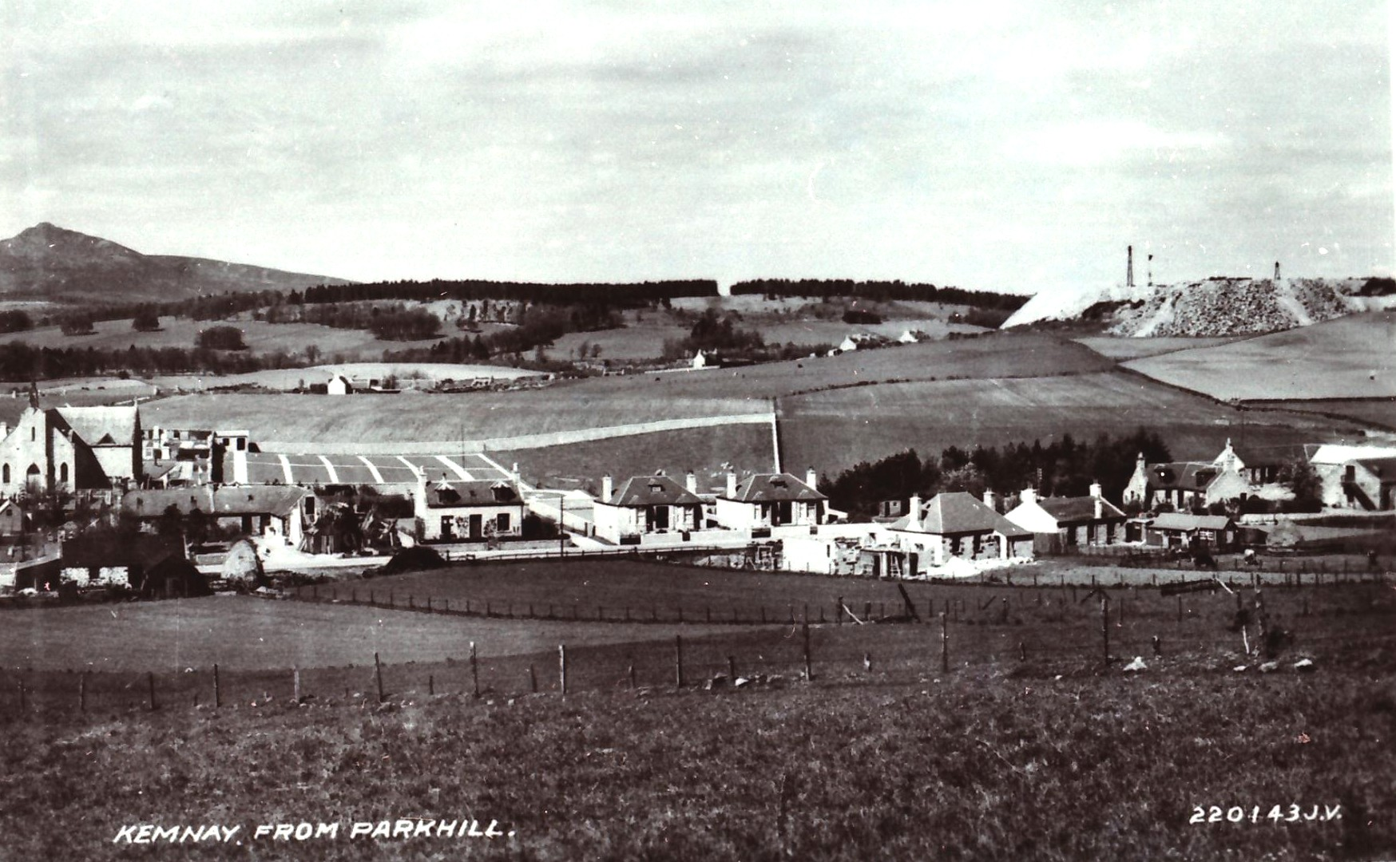
This month's picture moves forward to the early 1930s

