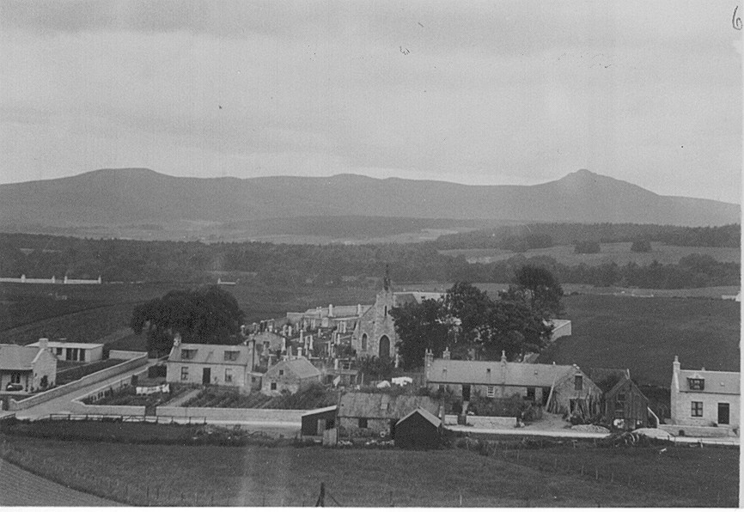
The above photograph was taken some three years after the one featured in April's newsletter and shows the changes that can happen in a short space of time. In the right foreground Louisville is looking pristine and new, having been recently built by Donald Stuart, supposedly for his parents but they never moved in. It was leased and was for many years the home of William Bremner who was watchmaker in the village and his sister Mary who kept house for him.
To the extreme left is Tornahaish, built by James Forbes, the blacksmith as a retirement home. The lease of the smiddy was taken by Robert Wright Duncan who was to work there for some forty years and was followed by his son John who had to retire on health reasons in 1962. Robert Duncan was well known in the area for his expertise as a gardener as will be seen by the orderly layout of his garden to the right of what is now Fraser Place.
The church is surrounded by mature hardwood trees. Some of these behind the church were removed during the course of forming the extension to the burial ground immediately behind the church in 1886. The rest were gradually removed over the years until in 1933, the one behind the smiddy house was removed by Robert Duncan and for his work he was granted three burial lairs for his family.

