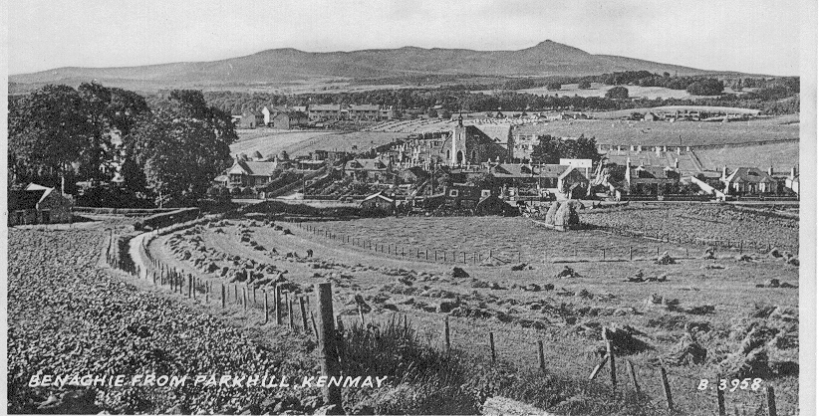
This postcard, dating from around 1950, lacks in fine detail but closer inspection brings out several changes from the earlier images. The hardwood trees round the manse still stand proud and in their glory. They were eventually felled during the 1960s. To the right of the trees may be seen the Cruden houses (the first of which was built in 1947) on what is now Burnett Road (then Donview Crescent) and Cairn Road. To the right of these is a park of stooks belonging to Glenallen which was then owned by the Chisholm family, and the buildings can be seen above the churchyard.
The ground behind Tornahaish was the Smiddy Croft, owned by Robert W. Duncan. It is now Wood Gardens. The park of oats in the foreground is the joiner's crop and the keen eyed will see the figure of James Downie (the writer's grandfather) teasing out the sheaves to dry them in preparation for 'leading'. The park of turnips in the left foreground is the glebe and then farmed by Nat Ferries of Wellbush.
Robert Duncan was a noted gardener and his orderly garden can be seen in front of the smiddy house, while to the left of the smiddy is the garage erected in the 1930s for his son George who later emigrated to New Zealand.
Above the two stacks of hay may be seen the wooden shed which acted as the joiner's garage before the workshop was extended in 1951. A number of memorials can be seen in the churchyard, mainly in the top area while the dairy cows of Kirkstyle farm graze in the field behind.
The road up Parkhill was little more than eight feet wide and heavy vehicles sometimes had a problem negotiating it. When David Middleton, the agricultural contractor changed from traction engine to tractor, the weight of the threshing mill pushed the lighter tractor down the hill and he was powerless to do anything until he reached the level ground at the bottom.

