CHRISTMAS GREETINGS
Now that December is with us our thoughts turn to sending greetings to our friends at home and around the world. How often do any of us stop to think when the sending of seasonal greetings came into being or how it has developed?
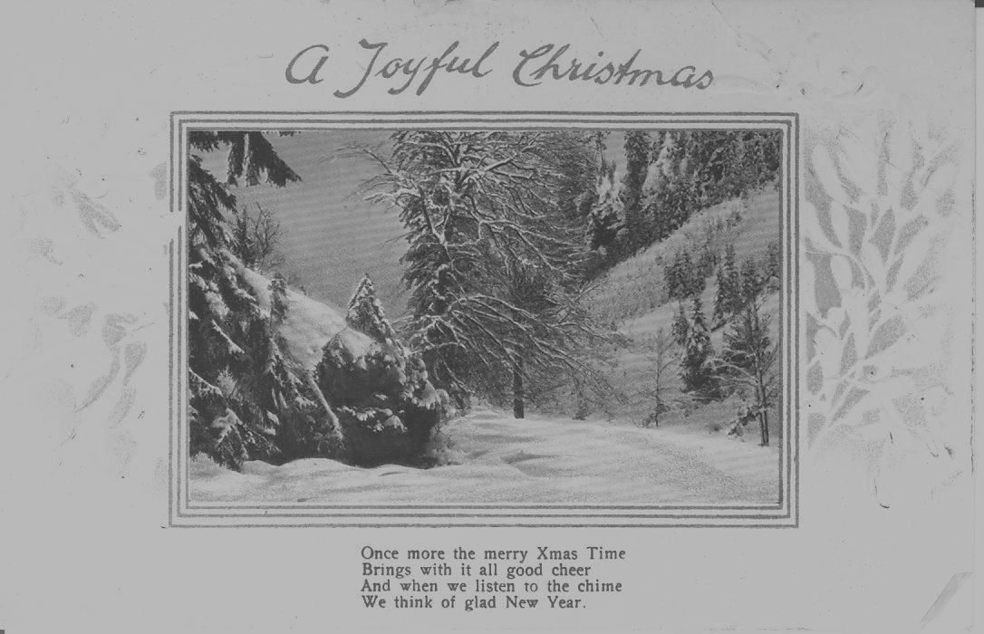
The first Christmas card was designed in 1843 by John Callcott Horsley at the request of his friend Sir Henry Cole. A thousand of these were printed and sold at one shilling (5p) each. Over the years the design of cards changed – some were embossed postcards with a seasonal view and message printed on them, as in the example shown below:
Few of the designs were exceedingly large, many of them being little more than the size of a business card; others were pierced round the edges to simulate lace, as in the image shown below.
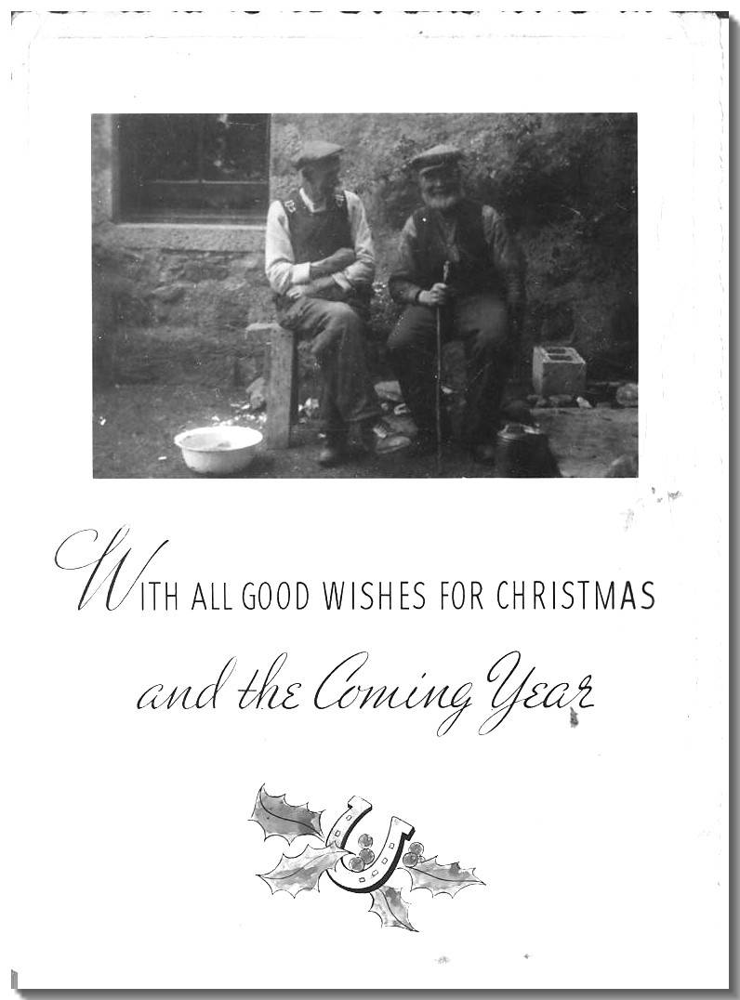
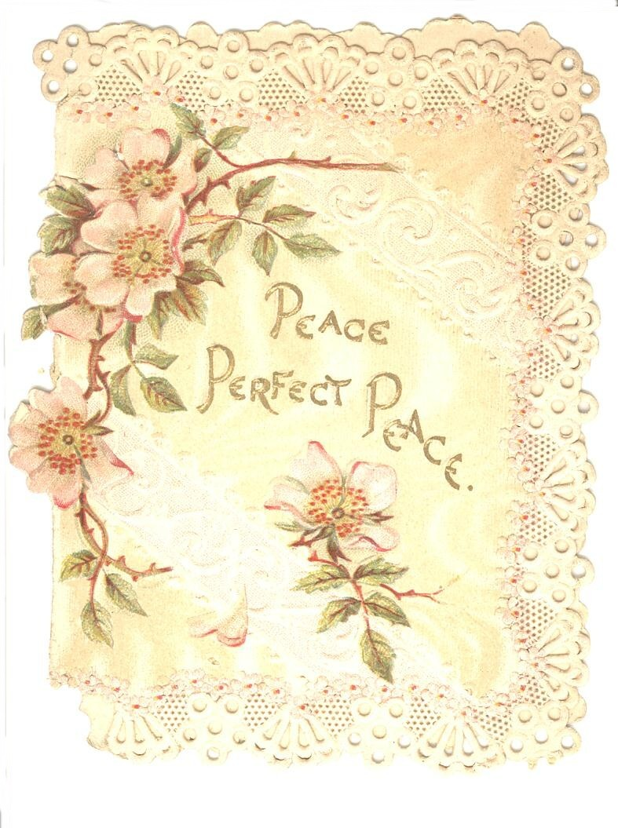

Sometimes a family might use a favourite photograph and have it mounted as in the example on the left which shows a photograph of the writer's grandfather, James Downie, pictured with Peter Smith who was the retired farmer at East Blairdaff where the picture was taken in the late 1940s while James Downie was carrying out some joiner work there. The message on the back reads "With all Good wishes from Blairdaff".
May all our readers have a pleasant Christmas.

