AN AULD POSTCARD
Another postcard of Kemnay featured recently on eBay. It is captioned U.F. Church, Kemnay and features a pristine new tower at the Free Kirk building on the hill above the school. It is addressed to “Mr Douglas Auld, Northfield, Box 144, Vermont, U.S.A.” It is postmarked at Kemnay on July 23 06 and at Northfield Vermont on Aug 3 1906.
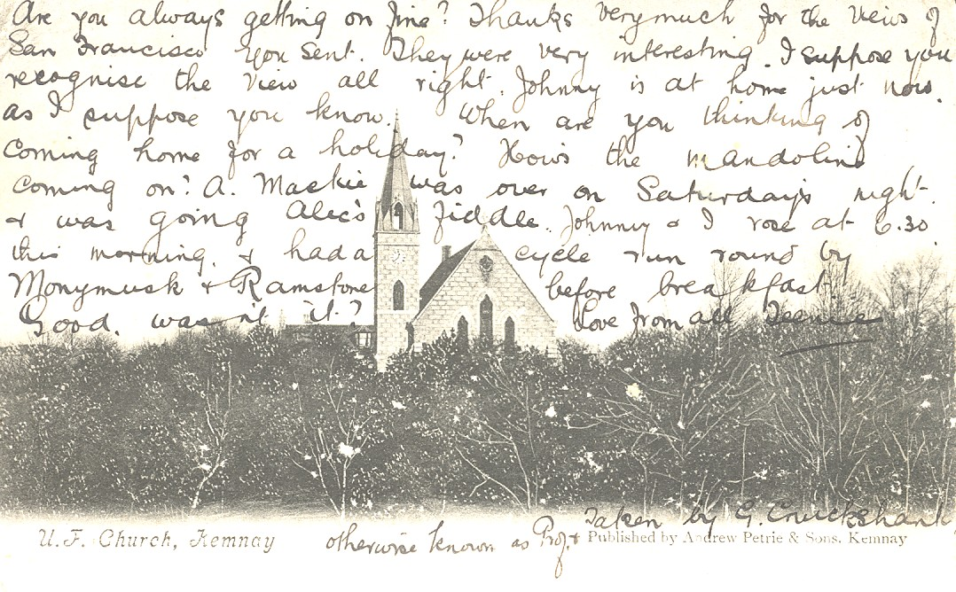
The message has been written over the image as the space on the other side indicates “This space may be used for communication for inland postage”
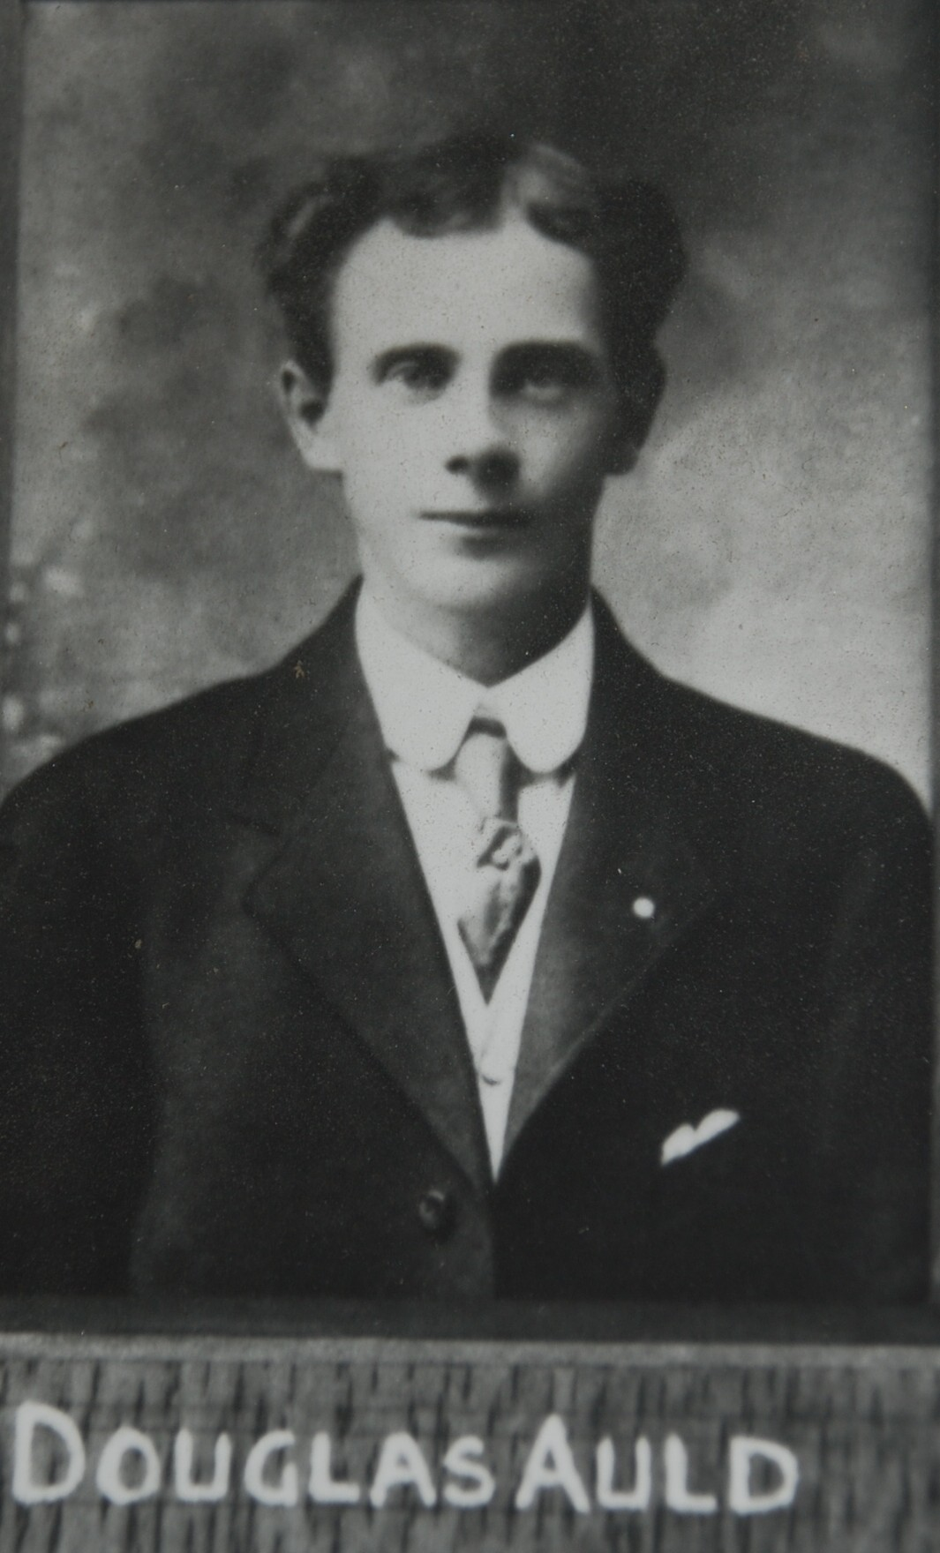
Douglas Auld was the son of the slater, William Auld, who built Dunrobin, off Kendall Road. In the 1901 census he is listed as a sixteen year old granite mason. Douglas served as a private in the 2nd Battalion Gordon Highlanders during the First World War. He was killed on 26th October 1917 and is commemorated on the Tyne Cot Memorial, Passchendaele, Belgium, Panels 135 to 136.
The image to the left is taken from the memorial which hangs in Kemnay Primary School.

