THE SMIDDY
Since time immemorial the blacksmith has been an integral part of every rural community in the land and he has been celebrated in poem and song. Longfellow's poem entitled 'The Village Blacksmith' starts; 'Under a spreading chestnut tree the village smithy stands.' The smiddy at Kemnay did not occupy such a romantic situation, but it stood beside the road passing through the kirk toon for many a long year.
In the Poll Book of 1696, we find one, 'William Dockers, smith, tennent in Pyketillum'. It is of interest that there is no mention, in this publication, of 'Kirkstyle' as a holding in the parish of Kemnay. In the Kirk Session minute of February 18 1694 we find 'to Wm. Dockers, Smy^{t}, for nails to Wm Milne, one of our poor his coffin.' At that time one could not nip round the corner to a shoppie for a packet of nails, all these items were hand made.
In the Kemnay House Archive in the 1770s we find a 'receipt by James Joss for iron smith work carried out at the mill, undated. Inside; receipt by George [?] for smith work at the mill payable by George Burnett, undated.' From August 1777 to August 1780, when the lists of receipts finish, receipts appear each year for bars of Swedish iron costing at today's prices around £650. There is no mention as to what use the iron was to be put, nor has any named blacksmith been found around that time. Scant knowledge has been gleaned as to what 'Swedish iron' was but it is understood to be a high quality product and could have been used in farrier work or ornamental ironwork.
George Andrew moved from Auchterless in 1808 to take over the smiddy at Kirkstyle, where he laboured until his death in 1862.
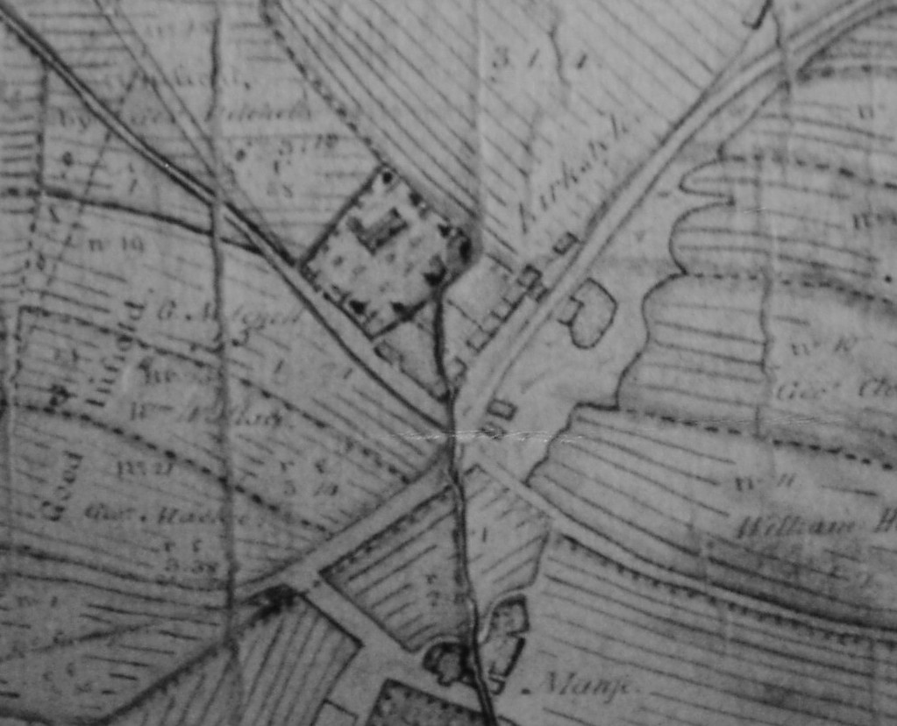
The earliest indication of the smiddy is in the estate map of 1792 which indicates a building (shown arrowed in the illustration) in the area of where the smiddy stood. There is every possibility that that building was replaced when the turnpike road was built in the mid 1820s.

