ROSEHILL
In January 1880 Peter Philip, a farmer in Craigearn, received a 99 year building lease from A G Burnett, the annual rental of which was £2. He erected the house known as Rosehill in Victoria Terrace, requiring no financial help to do so.
In 1881, Peter, aged 70, was staying there with his wife Christina aged 56. Christina died sometime during the ensuing ten years as in 1891 Peter had a sixteen year old housekeeper, Mary Geils from Keithhall and two grand daughter were staying with him, Georgina Philip aged 9 and Helen aged 8 both born in Lanark. Also staying in the house were Margaret Reid aged 32, a self employed shirtmaker and her 37 year old brother Alexander who was a widower and a labourer. Portsoy teacher, 34 year old Isabella D Craik was staying with her 30 year old sister Helen who was a self employed dressmaker.
Peter Philip sold the property to James Burr, a mason, for the sum of £210 in April 1893. James Burr was born in Tarves and his wife Christian Horn was born in Fyvie. In 1891 they were staying at Gladstone Cottage with their son James aged 1 year. Twins, Robert and Christina were born the year they moved into Rosehill.
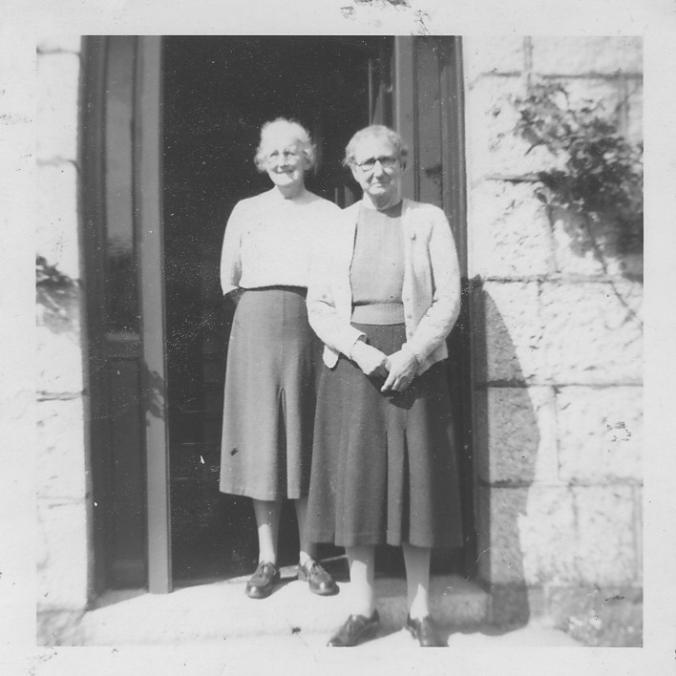
James Burr moved to Elgin and Robert emigrated to Johannesburg while Christina, or Chrissie, as she was better known to the village folk remained at home to look after her parents, her father dying in 1915 and her mother in 1936. It was not uncommon for a spinster daughter of that era to spend her life thus, and the only recompense she received was to have the property passed to her on the death of her parents, and with no other income, other than state benefits to live on these poor people were left with a house and no money for its upkeep. Chrissie eked out her income by continuing to let out part of the house while she stayed in a couple of rooms. Such was the precarious state of her finances that in 1962, she borrowed £300 with interest repayments at 6½%. This loan she paid off in 1972 and at her death in August 1975, the house, which was still on a building lease, was valued at £5000.
In her will, amongst several private bequests, she left £100 to Kemnay Parish Church, to be used at the discretion of the Kirk Session.
Left, Chrissie Burr with Mary Bremner at the door of Louisville

