BLETHERY WELL
When houses began to be built in the village from the 1860s onwards, some were fortunate enough to procure a water supply within the site but others were not so fortunate. Traces of some of these wells may be found in the gardens of some of the older houses today. In order to supply water to properties a pipe was led from the blethery well round the village. This pipe ran quite level as there was no initial head of water to provide pressure. Small pumps were installed at individual properties by which the property owners were able to draw water up from the pipe. A circular stone building was erected over the spring with a conical roof and a door for access.
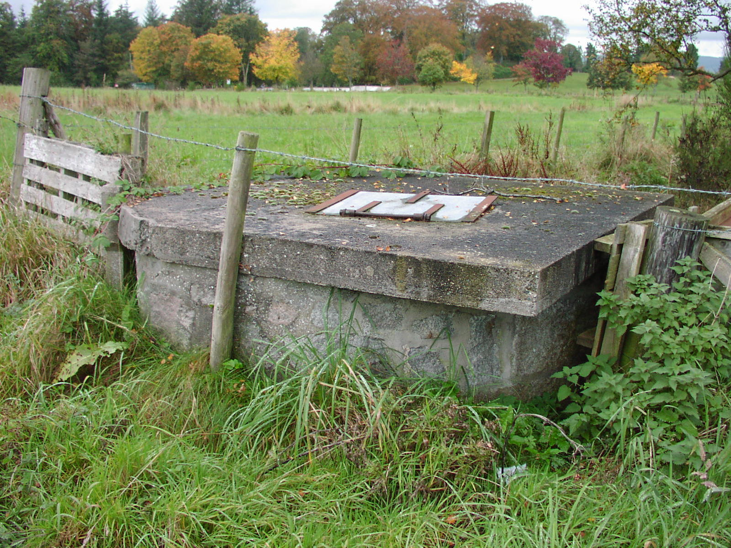
A new supply from Dalfling on the lower slopes of Bennachie was installed in 1900 at a cost of £3800. This had storage capacity at source but nothing in the village. At peak times, some of the higher properties in the village experienced considerable pressure drop and in 1930 a storage cistern was erected at Parkhill. The water house at the blethery fell into disrepair and eventually collapsed. During the 1960s further problems with water pressure were experienced and works were carried out at the blethery and a concrete roof was put on but nothing further was done. Building works in the vicinity of the blethery affected the supply and the pressure today is nothing to what it was in the years past when water bubbled up through the sands of the burn all the way to Bogbeth Road. The scene today is completely different with the burn completely overgrown and the water out of sight altogether.
The blethery well as it is today

